

Flood Management Strategy Port Phillip and Westernport 2021 to 2031
Acknowledgement of Country
Melbourne Water respectfully acknowledges Aboriginal and Torres Strait Islander peoples as the Traditional Owners and custodians of the land and water on which all Australians rely. We pay our respects to Bunurong, Boon Wurrung, Wurundjeri Woi wurrung and Wadawurrung, their Elders past, present and future as Traditional Owners and the custodians of the land and water on which we rely and operate.
We acknowledge and respect the continued cultural, social and spiritual connections of all Aboriginal Victorians, and the broader Aboriginal and Torres Strait Islander community have with lands and waters, and recognise and value their inherent responsibility to care for and protect them for thousands of generations.
Melbourne Water acknowledges Aboriginal Victorians as Traditional Owners and in the spirit of reconciliation, we remain committed to working in partnership with Traditional Owners to ensure meaningful ongoing contribution to the future of land and water management.
Traditional Owner organisations were given the opportunity to provide content and feedback on the refresh of this flood strategy.
Acknowledgement
This strategy was developed through a collaborative process with partners and stakeholders across the region.
Melbourne Water is grateful for the energy, experience and expertise of everyone who was involved in developing this shared understanding of our collective vision, the challenges in the region and the opportunities for improving flood management delivery.
The Flood Leadership Committee
Melbourne Water prepared this document with governance from the Flood Leadership Committee, which included representatives from:
- Cardinia Shire Council
- City of Melbourne
- City of Port Phillip
- Department of Environment, Land, Water and Planning
- Emergency Management Victoria
- Insurance Council of Australia
- Melbourne Water
- Moonee Valley City Council
- Mornington Peninsula Shire Council
- Victorian Planning Authority
- Municipal Association of Victoria
- South East Water
- Victoria State Emergency Service
- Wyndham City Council

Contents
Contents 3
Preface 5
Why did we need to refresh the flood strategy? 5
Our key steps 5
Approval and endorsement 6
Summary 7
Our region 7
Climate change and urbanisation are increasing flood risk 7
Many organisations have a role in managing flooding 8
Community-based approach 8
Our long-term vision 9
How we get there 9
Section 1 Why we need a flood strategy 12
Introduction 12
Flooding in the Port Phillip and Westernport region 12
A changed landscape – and increasing risks 17
Types of flooding 19
Types of flood 19
Severity of flood 19
The impact of flooding 20
The cost of flooding 20
The impact of flooding on people 21
The impact of flooding on the natural environment 21
The challenge of climate change 21
The challenge of population growth and urban density 23
The opportunity to empower the community 23
The opportunity to contribute to social and environmental outcomes 24
Section 2 The processes for managing flooding in our region 25
The flood management process 25
Roles and responsibilities in preparing for and managing flood risk 27
Summary of activities and responsibilities 27
Managing the vital drainage system 29
Policies and strategies influencing flood management 29
What we have achieved since the last flood strategy 31
Section 3 A shared vision for Port Phillip and Westernport 36
The Flood Strategy in Action 36
Vision, objectives, 10-year outcomes and focus areas 36
Section 4 The focus areas 39
About the focus areas 39
Focus Area 1: Fit-for-purpose information 39
Focus Area 2: Empowering communities 41
Focus Area 3: Flood effects mitigation 43
Focus Area 4: Land use planning 47
Focus Area 5: Challenges of climate change 48
Focus Area 6: Multiple benefits embedded in decision-making 50
Focus Area 7: Clarifying roles and responsibilities 52
Focus Area 8: Emergency agency preparedness and response 53
Focus Area 9: Flood recovery 55
Section 5 Governance, endorsement and implementation 56
Governance, Implementation and Monitoring 56
The governance framework 56
Flood Leadership Committee 56
The endorsement process 56
Implementation 57
Section 6 Monitoring, evaluation, reporting and improvement 58
Embedding accountability, learning and continuous improvement 58
Evaluating the strategy 58
Monitoring the strategy 59
Reporting 59
Glossary 60
Abbreviations 62
Bibliography 63
Figures
Figure 1 Vision, objectives, 10-year outcomes, focus areas and five-year Action Plans × 2 10
Figure 2 Mapped flooding in Port Phillip and Westernport 13
Figure 3 What happens when it floods 14
Figure 4 A timeline of flooding in our region 17
Figure 5 Estimating annual average damage 20
Figure 6 The influence of climate change on the water cycle 22
Figure 7 Flood management mitigation, response and recovery 25
Figure 8 Stages in flood management – before, during and after 26
Figure 9 Flood management and related policies and strategies 30
Figure 10 A selection of flood management strategy achievements 32
Figure 11 Vision, objectives, 10-year outcomes, focus areas and five-year Action Plans × 2 37
Figure 12 Making best use of resources – choosing the right approach in each location 45
Figure 13 Governance framework 56
Tables
Table 1 Annual review and planning process 57
Table 2 Key evaluation questions 59

Preface
Melbourne Water prepared this Flood Management Strategy Port Phillip and Westernport, together with our partners.
Our partners are all organisations in the region who have flood management responsibilities, including local and state government, water authorities and emergency services.
Reflecting this successful partnership, the pronoun ‘we’ throughout this document refers to all flood management agencies in the region.
The context of this strategy is to enhance community safety. We developed the strategy to ensure that we are working together to enhance our understanding of the problem of flooding in a rapidly changing context of climate change and increasing urbanisation. We wanted to make sure we have the right mix of solutions and embed a process of continuous improvement.
This strategy is part of a framework of related legislation, policies and strategies and reflects national and state best-practice standards and guidelines.
This is a ‘refresh’ of the 2015 Flood Management Strategy Port Phillip and Westernport.

Why did we need to refresh the flood strategy?
We need to ensure we remain prepared in what is a rapidly changing context. Climate change and urbanisation significantly increase our flood risks. We now have more information about climate change and how it affects our region, and our population is growing at a faster rate than ever before.
We want to consolidate what is working in how we manage flood risk, and ensure we are constantly improving what we do, so that we continue to make the region safer for our community.

Our key steps
The refresh process was rewarding. We began the process in early 2019, starting with extensive consultation and a scan of national and international best-practice approaches for flooding. Together, we:
- reviewed the existing vision and objectives
- identified key directions
- determined the focus areas and actions to achieve the objectives
- developed an approach of shared responsibility and accountability
- included monitoring, review and evaluation processes in the strategy.
We reviewed past achievements – our successes and disappointments – reset our collective long-term vision, articulated 10-year objectives and outcomes, and developed the first of two, five-year action plans that will span the life of the strategy.
Our vision directed our work, and we applied best-practice approaches to collectively managing flood risk, including approaches to land use planning; flood information; education; flood warnings; emergency response and recovery; and constructing, maintaining or upgrading our drainage, flood management infrastructure and multifunctional assets. These approaches respond to flood risks – before, during and after flood events.

Approval and endorsement
The Flood Leadership Committee and the Melbourne Water Board of Directors endorsed the strategy and accompanying action plan in 2021. Partner organisations that have endorsed the strategy prior to publication are identified in the document. Implementation and monitoring will be a collective effort, coordinated by Melbourne Water.

Summary
The Flood Management Strategy Port Phillip and Westernport is a 10-year strategy that aims to enhance the flood resilience of the region. It builds on our strong history of flood management, and the previous 2015 strategy, to set a path within our current circumstances.
In this strategy, we set out the context for flooding in the region – one that is rapidly changing, requiring us to refresh our strategy to make sure we continue to evolve in the way we manage flood risk.
We have identified key directions in this strategy that provide a greater emphasis on managing climate change, empowering diverse communities, and managing flooding to achieve multiple benefits for water security, liveability and sustainability.
The strategy recognises the roles and responsibilities of partner organisations in managing flood risks and the need for effective collaboration. We have an opportunity to take a holistic approach to water management including catchment-wide, place-based and integrated water management approaches.
This strategy is one part of a framework of legislation, policies and strategies that aim to reduce the risk posed by flooding, including to community safety. It will never be possible to entirely remove flood risk from our region, but we can work together to better manage it into the future.

Our region
The Port Phillip and Westernport region extends approximately 13,000 square kilometres, from high in the Yarra Ranges to the east, Ballan in the west, Lancefield in the north, and Mornington Peninsula, and Phillip and French Islands in the south.
Flooding poses risks to people, property, infrastructure and the environment. Flood impacts can include deaths, injuries, property damage, social disruption, and loss or disruption of critical infrastructure and services.
An extensive network of flood infrastructure has been built over many years to reduce the impacts of flooding. However, it is not feasible to completely remove flood risk from the region. Some parts of Melbourne are built on former swamp lands or low-lying areas. In other flood prone areas there is no longer the space to build new flood infrastructure.
In any given year, it is estimated there are over 200,000 properties across the region that have at least a 1% chance of flooding. The annual average damage caused by flooding in the region has been estimated at $735.5 million.
While flooding is natural and beneficial to particular environments, flooding can also damage and degrade waterways with rapid, high-volume flows, litter and pollutants.

Climate change and urbanisation are increasing flood risk
Climate change and urban development are increasing flood risk in the Port Phillip and Westernport region.
Climate change will continue to increase flood risk as the intensity of rainfall events increases, severe storms become more common, and the sea level rises.
At the same time, the population of Greater Melbourne is growing rapidly – it is projected to increase from five million in 2018 to nine million by 2056. Population growth and the resulting urbanisation exacerbate flooding by increasing the extent of impervious surfaces, such as roofs and roads, and reducing the extent of gardens. This increases stormwater flows rather than holding and infiltrating rainwater. Further, flow paths can be blocked at the local scale by development and additional buildings and fences.
The extent of urbanisation in some areas also prohibits and constrains the opportunities for cost-effective, large scale flood infrastructure.
Importantly, this changing context means we have more to learn and apply. While our existing approaches to flood management will continue to play a critical role in flood management, we also need to find innovative approaches to reduce flood risk.

Many organisations have a role in managing flooding
Many organisations manage flooding in the region including councils, water authorities, state government and emergency management services. We have responsibilities for protecting people, infrastructure, assets, economic activity and the environment. We work together as partners and with communities to understand, prepare for, manage and recover from flooding, collectively.
We manage various types of flooding including that of our river systems (riverine flooding), our drainage infrastructure (overland and flash flooding) and along our coastlines (coastal flooding or tidal inundation and sea level rise).
We have extensive experience and a strong understanding of flooding in the region, providing a sound foundation for managing flood risk. We manage an extensive drainage network across the region with significant assets that convey stormwater flows and reduce flood risks.
Our approach is driven by accountabilities and obligations as stated through legislation (and subordinate legislation and policies), and incorporates flood and emergency management activities before, during and after flood events.
The Victorian Floodplain Management Strategy 2016 is the Victorian Government’s policy framework for floodplain management and establishes the policy basis for floodplain management strategies. Focus Area 8 details arrangements for managing all emergencies and provides details about roles for agencies in Victoria.

Community-based approach
This document has been developed by partners to reflect our roles and responsibilities and meet the vision, objectives and outcomes of the strategy. The safety, resilience and well-being of the community is at the forefront of our work. We have responsibilities towards communities to inform, protect and support them in relation to flood risks. We work to empower communities to help them prepare before, during and after flood events. We engage with communities to enhance our programs and services, so we are responsive to community needs.
Communities include individuals, groups and businesses. We recognise that communities are diverse and experience different vulnerabilities and challenges in relation to flood risks. Throughout the strategy and action plan, we identify our roles, responsibilities, approaches and opportunities to engage and empower communities. We are committed to prioritising the best outcomes for the community in the region as part of our collaborative, catchment-based approach.

Our long-term vision
Our vision includes the term ‘resilient’. Flood resilience is multi-faceted and needs to be incorporated into every aspect of flood management.
We know that floods will happen, so we need to plan and prepare for flooding. We can take action to reduce the impact of flooding through a range of approaches. Where we can, we will work to prevent flooding, and where it is not possible, we can reduce the impact and risk through a range of tools and measures.
As partners, we have responsibilities for developing flood information, urban planning and development, managing infrastructure including drains and roads, community awareness and education, and emergency response and recovery. We need to work with organisations, businesses and the community to help people to better understand the importance of preparing for flooding, and to know how to respond in flood events to reduce the impacts.
We also need to work with communities to ensure that we recover quickly, learn from our experiences and adapt to increase our flood resilience over time.
Flood resilience recognises that we are living in a dynamic, changing context, managing the impacts of climate change and urbanisation. Developing greater flood resilience can improve community safety, and the liveability and sustainability of the region.

How we get there
Our strategic approach is directed by our vision and objectives, with associated 10-year strategy outcomes (see Figure 1). Under each outcome, the strategy proposes key focus areas, which guide the actions contained within the action plan.
The focus areas and actions comprehensively apply best-practice approaches to collectively managing flood risk, including approaches to land use planning, flood information, education, flood warnings, emergency response and recovery. It also includes constructing, maintaining or upgrading drainage and flood management infrastructure and multi-functional assets.
Figure 1 Vision, objectives, 10-year outcomes, focus areas and five-year Action Plans × 2
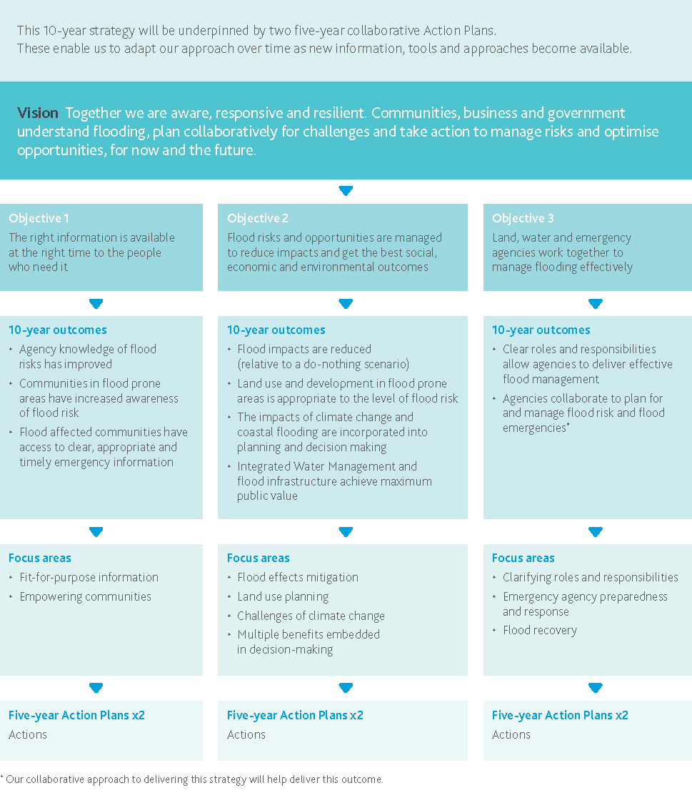
Vision
Together we are aware, responsive and resilient. Communities, business and government understand flooding, plan collaboratively for challenges and take action to manage risks and optimise opportunities, for now and the future.
Objective 1: The right information is available at the right time to the people who need it
- 10-year outcomes
  - Agency knowledge of flood risks has improved
  - Communities in flood prone areas have increased awareness of flood risk
  - Flood affected communities have access to clear, appropriate and timely emergency information
- Focus areas
  - Fit-for-purpose information
  - Empowering communities
- 5-year Action Plans × 2
  - Actions
Objective 2: Flood risks and opportunities are managed to reduce impacts and get the best social, economic and environmental outcomes
- 10-year outcomes
  - Flood impacts are reduced (relative to a do-nothing scenario)
  - Land use and development in flood prone areas is appropriate to the level of flood risk
  - The impacts of climate change and coastal flooding are incorporated into planning and decision making
  - Integrated Water Management and flood infrastructure achieve maximum public value
- Focus areas
  - Flood effects mitigation
  - Land use planning
  - Challenges of climate change
  - Multiple benefits embedded in decision-making
- 5-year Action Plans × 2
  - Actions
Objective 3: Land, water and emergency agencies work together to manage flooding effectively
- 10-year outcomes
  - Clear roles and responsibilities allow agencies to deliver effective flood management and emergency services
  - Agencies collaborate to plan for and manage flood risk and flood emergencies (our collaborative approach to delivering this strategy will help deliver this outcome.)
- Focus areas
  - Clarifying roles and responsibilities
  - Emergency agency preparedness and response
  - Flood recovery
- 5-year Action Plans × 2
  - Actions

Why we need a flood strategy

Introduction
“It’s impossible to stop natural disasters from happening. But it is possible to do more to make our communities safer.”
Australian Business Roundtable for Disaster Resilience and Safer Communities, 2020
Floods are a natural occurrence in the Australian landscape, however they can have significant impacts. In our region we have built an extensive network of drainage and flood infrastructure that reduces the risk and impacts of flooding on people, property and the environment.
Despite our infrastructure netwo, flood risks are growing due to increasing rainfall intensity and sea level rise as a result of climate change. At the same time, urban development is increasing stormwater flows. There are smaller gardens and less green space to soak up rainfall and our population has been growing faster than ever before, exposing more people to the disruption of flood events.
The extent of urbanisation in some areas also prohibits and constrains the opportunities for cost-effective, large scale flood infrastructure.
These increasing flood risks are the reason why we need to refresh the flood strategy to ensure our approaches continue to evolve so we can keep building resilience to flooding and making the region safer for our community.
The impact of flooding can be extreme. Floods can cause loss of life and injury. People can be dislocated from their homes and from their communities. It takes time to recover from stress and disruption, damage to homes and businesses, and the distressing loss of belongings, gardens and pets.
Floods cause damage to property and infrastructure, interfere with transportation and have flow-on impacts to the economy. Significant floods can damage our natural environment in ways that can be permanent.

Flooding in the Port Phillip and Westernport region
The Port Phillip and Westernport region is home to over five million people and businesses within Greater Melbourne, surrounded by rural and farming areas. The natural environment supports the region through five major river systems. Iconic species, forests and waterways are part of the region’s valuable biodiversity.
An extensive network of drainage infrastructure has been built in the region. Drainage systems that were built as part of the earlier development of the region were not designed to hold the volumes of water that now flow through our landscape, or are likely to occur as the population of the region increases and climate change alters our rainfall patterns.
It is not technically feasible to remove flood risk from the region, no matter how much money is invested. Parts of Melbourne are built on former swampland or low lying areas, and in other areas such as inner-suburbs there is not the space to build new infrastructure.
Figure 2 Mapped flooding in Port Phillip and Westernport
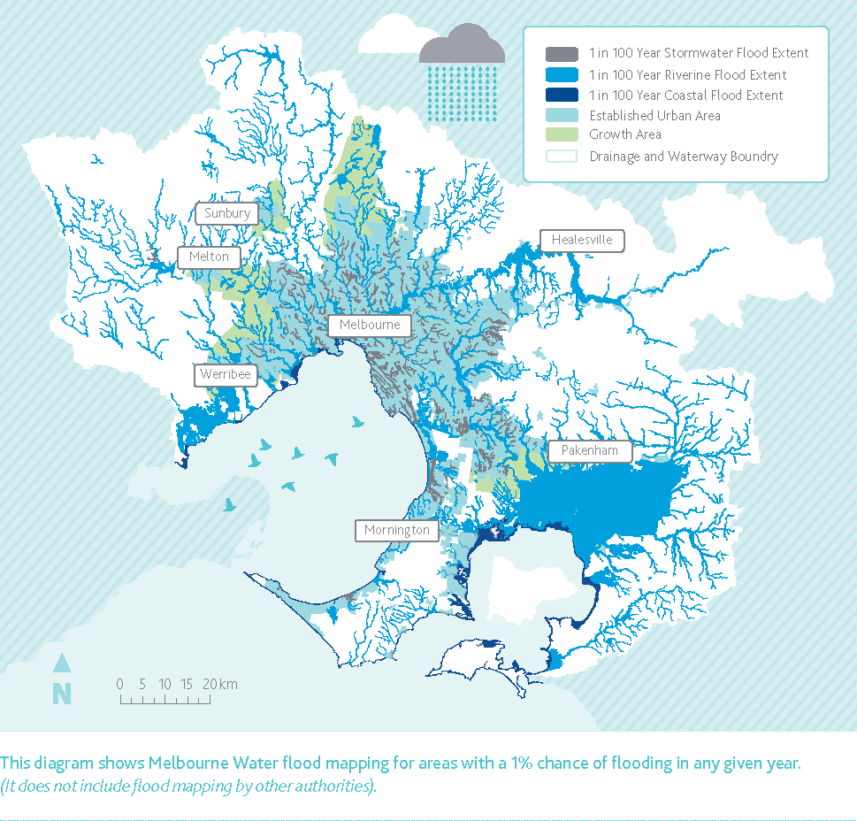
This diagram shows Melbourne Water flood mapping for areas with a 1% chance of flooding in any given year. (It does not include flood mapping by other authorities).
When flooding occurs in natural environments, it brings nutrients to replenish the floodplain. However, when flooding affects property, buildings and assets, it can have damaging and costly consequences.
Figure 3 What happens when it floods
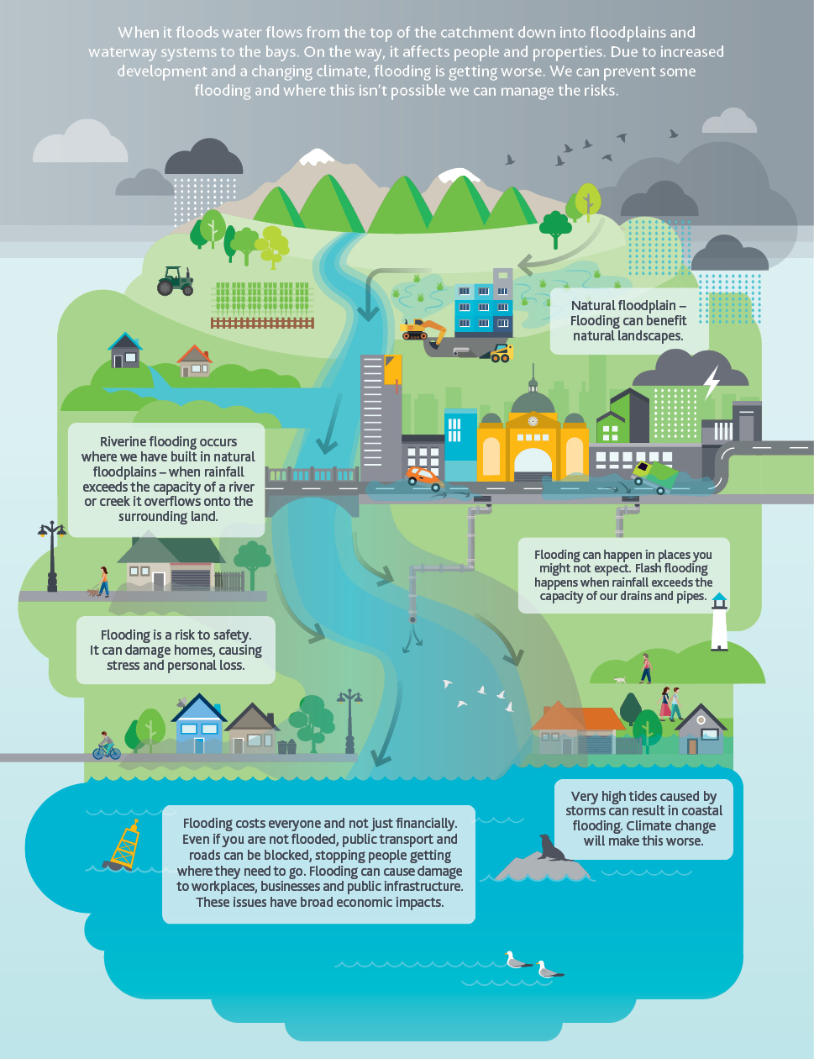
When it floods water flows from the top of the catchment down into floodplains and waterway systems to the bays. On the way, it affects people and properties. Due to increased development and a changing climate, flooding is getting worse. We can prevent some flooding and where this isn’t possible we can manage the risks.
- Natural Floodplain – Flooding can beneﬁt natural landscapes.
- Riverine ﬂooding occurs where we’ve built in natural ﬂoodplains – when rainfall exceeds the capacity of a river or creek it overﬂows onto the surrounding land.
- Flooding can happen in places you might not expect. Overland ﬂooding happens when rainfall exceeds the capacity of our drains and pipes.
- Flooding is a risk to safety. It can damage homes, causing stress and personal loss.
- Very high tides caused by storms can result in coastal ﬂooding. Climate change will make this worse.
- Flooding costs everyone and not just ﬁnancially. Even if you aren’t ﬂooded, public transport and roads can be blocked, stopping people getting where they need to go. Flooding can cause damage to workplaces, businesses and public infrastructure. These issues have broad economic impacts.
The Time of Chaos
N’arweet Dr Carolyn Briggs, The Boon Wurrung Foundation
Many years ago, the biik (land) we now call greater Melbourne extended right out to the warreeny (ocean/sea). Nairm (Port Phillip Bay) was then a large, flat, grassy plain. The Yarra River, as it is known today, flowed out across this flat plain into the warreeny. For the Boonwurrung, this wurneet (river/creek) was known as Birrarung (River of Mist).
This large plain was covered in buath (grass) and tarrang biik (woodlands) on which the Boonwurrung guleeny (men) hunted guyeem (kangaroo) and barraeemal (emu). The bagurrk (women) cultivated the murnong (yam daisy). They collected food from the wurneet (creek) and the warreeny, and harvested the iilk (eels) that migrated through there every year.
The Boonwurrung were the custodians of their biik, but traded with and welcomed people from other parts of the Kulin Nation. They obeyed the laws of Bundjil, who travelled as an eagle, and Waang, who travelled as a crow.
One day – many, many years ago – there came a time of chaos and crisis. The Boonwurrung and the other Kulin nations were in conflict. They argued and fought. They neglected their biik. The murnong was neglected. The animals were over-killed and not always eaten. The gurnbak (fish) were caught during their spawning season. The iilk were not harvested.
As this chaos grew, the warreeny became angry and began to rise. The wurneet became flooded and eventually the whole flat plain was covered in baany (water).
It threatened to flood their whole birrarang-ga (country).
The people became frightened and went to Bundjil, their creator and spiritual leader. They asked Bundjil to stop the warreeny from rising.
Bundjil was angry with his people, and he told them that they would have to change their ways if they wanted to save their biik. The people thought about what they had been doing and made a promise to follow Bundjil.
Bundjil walked out to the warreeny, raised his tjeera (spear) and directed the warreeny to stop rising. Bundjil then made the Boonwurrung promise that they would respect the laws.
The baany never subsided, but stayed to create a large bay that the Boonwurrung called Nairm. Today it is known as Port Phillip Bay. The warreeny took away much of the biik of the Boonwurrung and much of their birrarang-ga was reduced to a narrow strip of coastline.
The Boonwurrung learnt from their mistakes. They returned to their old values and the laws of Bundjil. They took greater care of the biik of Bundjil and the bubup (child) of Bundjil.
They met with other Kulin people and sorted out their differences through sports, debates and dance.
One of the most important laws that Bundjil required to be obeyed was for Boonwurrung people to always welcome visitors and to require all visitors to make a promise that they would obey the laws of Bundjil, not hurt the biik of Bundjil and not harm the bubup of Bundjil.
Today, the wurneet that once flowed through this large flat plain still flows under the Nairm.
© N’arweet Dr Carolyn Briggs AM – The Boon Wurrung Foundation Ltd

A changed landscape – and increasing risks
Since European settlement, urban and agricultural development has significantly changed the landscape.
The volume of floodwater has increased by clearing forests and increasing impervious surfaces; now, water flows more swiftly off the surface of cleared and paved landscapes, instead of filtering into soils. This increases flooding along waterways and on low-lying land. Rainwater can exceed the capacity of our drainage systems. High tides and coastal surges can cause flooding which will worsen as sea levels continue to rise.

A short history of flooding
Floods are a part of the natural water cycle and have always occurred in our region. The history of Port Phillip and Westernport has been marked by many serious and damaging floods. Before European settlement, Aboriginal inhabitants of our region already had a depth of knowledge of flooding from living on the land. They harvested food and other resources from waterways and floodplains.
These floodplains retain important cultural significance.
This timeline shows some of the key flood events throughout Melbourne’s history.
Figure 4 A timeline of flooding in our region
Year | Event
1,000BCE | Rapid sea level rise forms Port Phillip Bay. The Kulin people live in harmony with nature and seasons, caring for land, water and sea.
1803 | Surveying Port Phillip, James Flemming on the ‘Cumberland’ notes flood marks on trees along the lower Yarra River that are 20 feet (6 metres) above the ground.
1835 | John Fawkner waits in the bay for five days on the ‘Enterprize’ before the floodwaters ease and they can enter the Yarra River.
1839 | The Yarra River bursts its banks. European settlers experience their first major flood inundation on Christmas Day.
1849 | A swirling mass of furniture, poultry and wood went washing down the Yarra River after a flood is caused by a big snow melt.
1860 | A deluge of rain in the Yarra River, that continued unabated for almost 24 hours, hits the Central Business District of Melbourne, with water swamping Bourke Street, Collins Street, Elizabeth Street and Flinders Street.
1863 | The Yarra River bursts its banks twice in a year. The goldfields in the Upper Yarra are in complete disarray. Bridges, fences, crops and livestock, and the Horticultural Burnley gardens, wash away.
1891 | The Great Flood leaves 3,000 people homeless. Over two days and two nights, floodwaters reach the eaves of houses and second-floor balconies. Residents row down Melbourne’s streets.
1906 | The highest flood affecting the Maribyrnong floodplain hits Footscray and Kensington hard, with waters recorded at 5.18 metres.
1923 | Along the Yarra River, severe flooding hits large parts of Melbourne, including Hawthorn, Abbotsford, Belgrave and Ferntree Gully. The deluge washes away bridges, rips up rail, and damage from landslides impacts the supply of water from the Yan Yean reservoir.
1934 | Over 48 hours more than 200 mm of rain falls over Melbourne and 350 mm falls in South Gippsland. A single lake forms from South Yarra to Warrandyte. Herring Island is completely under water. Around 6,000 people are made homeless and 36 people die.
1952 | Major floods affect Carrum, Aspendale and Chelsea.
1954 | Melbourne Central Business District and surrounding suburbs flood after 127 mm rain in 9.5 hours. Police call in army trucks as water rises alarmingly in Elwood canal.
1972 | White-capped waves lift car bodies and sweep them away down Elizabeth Street in Melbourne, which is pummelled with 78.5 mm of rain in one hour. Police roll up their trousers to rescue shoppers swept off their feet by the brown floodwaters.
1974 | The second largest flood on the Maribyrnong River occurs when 110 mm of rain falls over a 48-hour period. Flash flooding causes havoc. The Melbourne Board of Works installs monitoring devices to provide early warnings.
1984 | The Upper Yarra and Dandenong Creek has moderate flooding with 120 mm.
1989 | Thunderstorms move in from Port Phillip Bay and loom menacingly over St Kilda with lightning, strong winds, hail and torrential rain: 89 mm falls in one hour. Emergency grants are given to 330 people and 130 need temporary housing. The Insurance Council of Victoria estimates a damages bill of $16 million.
1991 | Melbourne is hit with a month’s worth of rain in 48 hours with 135 mm.
1993 | Major flooding along the Maribyrnong River finds the Anglers Tavern Lounge under nearly two metres of water. The river rises 3.8 metres with 150 homes damaged.
2002 | Brimbank suffers severe flash flooding with torrential rain and high winds for 18 hours with 66 mm rainfall. The storm causes $5 million in damages as businesses find themselves knee-high in flood water.
2003 | A severe storm sees $50 million in damages as 106.5 mm of rain falls in 2.5 hours across Melbourne. Flash flooding sends torrents of water waist-deep into schools, houses and shops. Motorists are rescued by boat on the Eastern Freeway.
2004 | A wild Summer storm batters Melbourne with 18 hours of torrential rain and high winds. Eastern and South Eastern suburbs worst hit with business owners knee-deep in water.
2005 | Up to 125 mm of rain falls in 24 hours in the Melbourne region with widespread riverine flooding. The RACV are called out to more than 500 car breakdowns and the Metropolitan Fire Brigade rescues passengers from car roofs.
2006 | Northcote and Coburg see 75.2 mm of rain in 30 minutes causing flooding.
2010 | End of the ‘millennium drought’. Major flooding across Melbourne’s South East.
2011 | Melbourne Central Business District, Elwood, Werribee and Bunyip record up to 150 mm of rain in 14 hours. More than 51 communities in western and central Victoria are affected. Over 1,730 properties experience damage. Follow-up rainfall events, including the aftermath of Tropical Cyclone Yasi, hit areas already experiencing major flooding.
2012 | In Koo Wee Rup 80 mm of rain falls over two days causing significant flooding.
2016 | Widespread flash flooding during record summer rains.
2018 | Melbourne turns on a wet and wild day for the 158th Melbourne Cup. The storm dumps more rain on Melbourne in two hours than in the previous two months. Victoria's SES carries out more than a dozen rescues.
2019 | Many minor river and flash flooding events across the Werribee, Yarra and Bunyip catchments. There are intense storms and localised flooding in Broadmeadows, Burwood and Mitcham.
2020 | New flood records set. In St Albans, 56.4 mm falls in 39 minutes. In Keilor, 8.2 mm falls in one minute, equating to 492 mm per hour. Minor flooding of Deep Creek, Yarra River and Dandenong Creek; localised flooding in Ringwood; flash flooding in Bacchus Marsh and Cranbourne.

Types of flooding
There are different types and severity of flooding.

Types of flood
(These definitions of the types and severity of flooding have been adapted from the 2016 Victorian Floodplain Management Strategy.)
Riverine flooding
Inundation of normally dry land when water overflows the natural or artificial banks of a stream, river, estuary, lake or dam. Riverine flooding generally excludes watercourses constructed with pipes or artificial channels considered as stormwater channels. Riverine flooding can be a slower process, occurring at a rate that allows advance warning. Flood waters may last for days.
Flash (stormwater) flooding
Inundation by local runoff caused by heavier than usual rainfall. Inundation can be caused by local runoff that exceeds the capacity of urban stormwater drainage systems; overland flows that are on the way to waterways; or riverine flooding causing urban stormwater drainage systems to back up and overflow. Flash flooding from the stormwater system tends to be rapid and dangerous due to the speed and depth of flows and difficulty in providing a timely warning to people.
Coastal flooding
Increases in coastal water levels above the predicted tide level resulting from a range of storm-related factors such as wind and waves. Coastal flooding in a storm surge gives some advance notice but sea level rise will mean some areas are permanently underwater.

Severity of flood
Minor flooding
Causes inconvenience. Low-lying areas next to watercourses are inundated. Minor roads may be closed and low-level bridges submerged. In urban areas inundation may affect some backyards and buildings below the floor level as well as bicycle and pedestrian paths. In rural areas removal of stock and equipment may be required.
Moderate flooding
In addition to the above, the area of inundation is more substantial. Main traffic routes may be affected. Some buildings may be affected above the floor level. Evacuation of flood-affected areas may be required. In rural areas, removal of stock may be required.
Major flooding
In addition to the above, extensive rural areas and/or urban areas are inundated. Many buildings may be affected above the floor level. Properties and towns are likely to be isolated and major rail and traffic routes closed.
Evacuation of flood-affected areas may be required. Utility services may be impacted.

The impact of flooding
The consequences of floods are serious for people living in affected areas and can have major economic repercussions for businesses and the community. Flooding impacts property, transportation, infrastructure and natural environments.

The cost of flooding
It is estimated there are over 200,000 properties across the region that have at least a 1% chance of flooding in a given year. The annual average damage (AAD) costs of flooding in the Port Phillip and Westernport region are estimated to be
$735.5 million. The annual average damage is calculated using economic inputs that quantify flood damage in monetary terms.
There are three categories of economic inputs including:
- direct damages to residential and commercial buildings, property and roads estimated at $319.8 million
- indirect damages such as disruption to public transport, loss of public services and emergency response estimated at $95.9 million
- intangible damages which are psychological and physical illness, memorabilia and flora and fauna estimated at $319.8 million.
The costs of intangible damages are found to be at least equal to the direct damage costs, however are likely to be even greater.
Figure 5 Estimating annual average damage
The annual average damage (AAD) costs of flooding in the Port Phillip and Westernport region are estimated to be approximately $735.5 million.
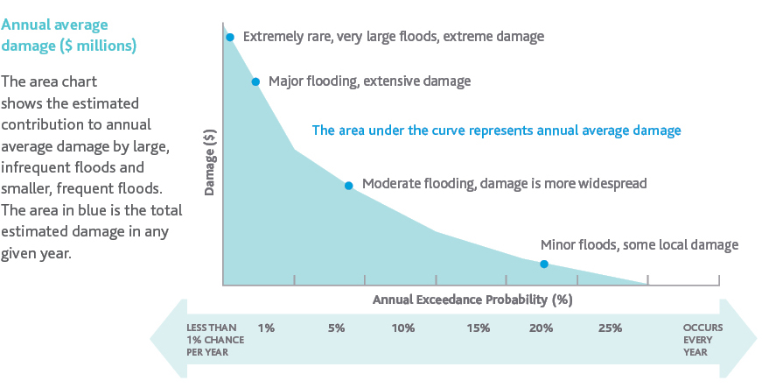

The impact of flooding on people
The personal and social costs of flooding can be significant. Floods can cause loss of life and injury.
The long-term stress and disruption arising from damage to homes and vehicles, and the loss of pets and possessions of personal value, are among the serious negative consequences.
Families can be displaced from their homes, sometimes for lengthy periods of time, while waiting for repairs to be completed. People can experience fear and helplessness during floods. Ongoing physical and mental health concerns have an impact on families and communities.

The impact of flooding on the natural environment
The natural environment is a complex and changing system providing clean air, clean water, food and carbon storage. Flooding can support natural floodplains through replenishing groundwater and wetlands, moving sediment and nutrients to areas that need them, and triggering fish and bird migration and breeding events. However, significant floods can also damage the environment, causing erosion and pollution, and transporting weeds, litter and debris to waterways and wetlands.
Damage to the natural environment may take time to repair and in some cases it is permanent. Environmental damage may cause further recreational and economic effects such as damage to fisheries.

The challenges and opportunities for the future
We have well-established approaches to manage flood risks including an extensive drainage system, land use planning, education and awareness and flood warnings. Major infrastructure will continue to be part of our flood solutions. Given the challenges the region faces from climate change and population growth, and the constraints of established urban areas, we need to expand our range of approaches to continue to build flood resilience in the region.
Our rapidly changing context presents challenges and opportunities, which this strategy addresses.

The challenge of climate change
Victoria’s climate has changed. We need to understand and prepare for the multiple and cumulative risks of climate change in our approach to managing flood risks. The increasing frequency and severity of hazards and hazard events, cost of these events, and impacts of climate change are well recognised in our legislative and emergency management framework.
In Australia, climate change intensifies and extends periods of heatwave, drought and water scarcity. As a result, we will continue to experience longer dry periods between rainfall events, reducing the availability of water to sustain green spaces that are critical for the health and wellbeing of people and environments.
A warmer atmosphere also holds more moisture so, when it does rain, rainfall is heavier. Climate scientists project that the intensity of heavy rainfall events will increase, and that the sea level will continue to rise, increasing the severity, regularity and risk of flood events in southern Victoria.
Figure 6 The influence of climate change on the water cycle
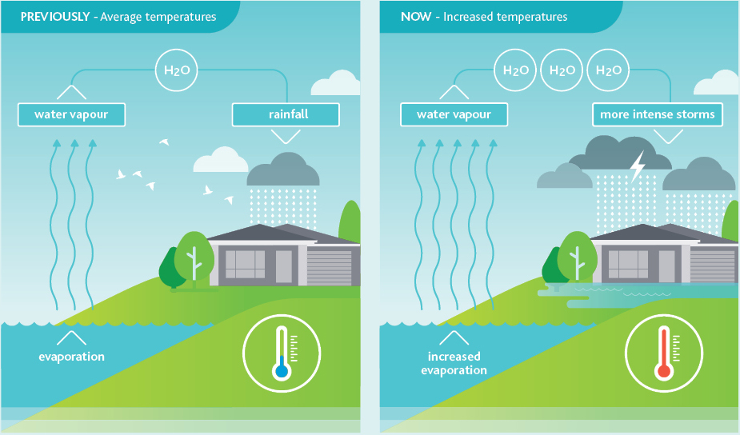
Sea level rises due to ice sheets on land melting and sea water expanding as it warms … Rising sea levels result in an increased risk of coastal erosion and inundation – threatening coastal ecosystems, local landscapes and crucial infrastructure.
Department of Environment, Land, Water and Planning, 2019
Communities are not equally affected by climate change. Some communities have greater exposure to extreme weather events, experiencing acute shocks. Some communities, including those experiencing acute shocks, also have chronic stresses that may be physical, economic and social, which make them more vulnerable to the consequences of flooding.
The 2015 Flood Management Strategy Port Phillip and Westernport identified climate change as one of the most important challenges we face.
Since this time, the community appetite for addressing climate change, and government policy, has changed. More than 50% of Australians see climate change as the most critical threat to Australia’s vital interests. Furthermore, 61% of Australians want steps taken now to address climate change even if the costs are significant. It is no longer a discussion of whether we should be addressing climate change, but how to address it.

The challenge of population growth and urban density
Victoria in Future 2019 is the official state government projection of population. It projects that Greater Melbourne’s population will grow from five million in 2018 to approximately nine million by 2056. It is estimated that up to 70% of new dwellings will be built in established urban areas.
When urban development occurs, at a minimum, we will not exacerbate flooding and where appropriate seek opportunities to mitigate risks both in the development and downstream. To do this, we need to make space for flood waters within the urban landscape and not create additional run-off. We need to plan for people’s safety and protect critical infrastructure.
These principles apply to developments in new suburbs and redevelopments in existing suburbs, while also involving their own challenges and approaches. For example, the nature of urbanisation can prohibit and constrain cost-effective opportunities for flood effects reduction.
The 2015 Flood Management Strategy Port Phillip and Westernport recognised the challenge of urban development and aimed to use the planning system to manage the flood risks associated with new development. This planning approach has worked well and is a very cost-effective way of managing flood risk. There is now an opportunity to look for additional ways to best leverage the planning system. Informed by the best available information, it is important to ensure that the planning system can continue to address the increased flood risks associated with population growth and climate change.

The opportunity to empower the community
The 2015 Flood Management Strategy Port Phillip and Westernport aimed to support communities to understand their flood risks and how they could manage them. At the start of the strategy, 41% of people, directly impacted by flooding, were aware of their flood risk. The strategy aimed to increase this to 58%.
Social research commissioned by Melbourne Water and Victoria State Emergency Service (VICSES) mid-way through strategy implementation found that only 44% of people who lived in flood-prone areas were aware of their risk, and only 34% felt prepared for flooding.
The small increase in awareness of flooding over the initial years of the strategy has highlighted the need to try different approaches to building the community’s awareness and preparedness for flooding. There are opportunities to better understand the needs of diverse communities, and then to engage and empower them to develop their awareness and knowledge of flooding.
They can be empowered to make informed choices and act – including seeking support when they need it and offering support in their communities.
Communities can also support flood management; they have on-ground information about where flooding is occurring and the effects, and they can identify locations that are important to them so that we can work to protect those places. We have an opportunity to work closely with the community to understand flooding in their suburb and develop solutions together.

The opportunity to contribute to social and environmental outcomes
We have an opportunity to take a holistic approach to water management and achieve multiple benefits from our programs and solutions.
By adopting an integrated water management (IWM) approach, we have an opportunity to develop catchment- wide and place-based responses to flooding that can provide multiple benefits. integrated water management considers the natural water cycle and all water supply and management systems as a single system, including drainage, waterway, water supply and sewage services.
With the 2015 Flood Management Strategy Port Phillip and Westernport, we started to consider flooding as part of an integrated water management approach. We undertook studies to understand the effectiveness of using an integrated water management approach to manage flooding. Now we have the opportunity to take this further by starting to develop integrated projects.
With this approach, we can direct flood waters to beneficial uses such as irrigation in parks and environmental flows to creeks; we can link assets such as wetlands to other vegetated spaces to support biodiversity; and we can allow safe access to assets to develop green, cool spaces to provide respite during periods of heat.
Delivering on multiple objectives at both catchment-wide and place-based scales requires the involvement of many partners. We need clear roles and responsibilities and effective collaboration to take up these opportunities.

The processes for managing flooding in our region
Although we cannot stop floods from occurring altogether, we can work collaboratively to reduce the risks and impacts of floods, and support recovery for communities, infrastructure, the environment and the economy.
There is a range of ways to manage flooding before, during and after flood events. Many partners have responsibilities for flood management across the Port Phillip and Westernport region, including governments, agencies and authorities as well as individuals.

The flood management process
Flood management is a collaborative process that addresses flood mitigation, response and recovery.
- Mitigation is defined by The Victorian Floodplain Management Strategy as reducing the impacts of flooding before a flood occurs.
- Response involves responding to flood events, in particular emergency management including providing warnings, protecting areas, and providing rescue and relief services.
- Recovery is defined by the State Emergency Management Plan as supporting people and communities affected by flooding to achieve a proper level of functioning.
Each stage of flood management involves a range of activities. The focus of this strategy is largely on the mitigation aspects of flood management (highlighted in Figure 7), because mitigation will have the best community outcomes. This work supports emergency response and recovery activities.
Figure 7 Flood management mitigation, response and recovery
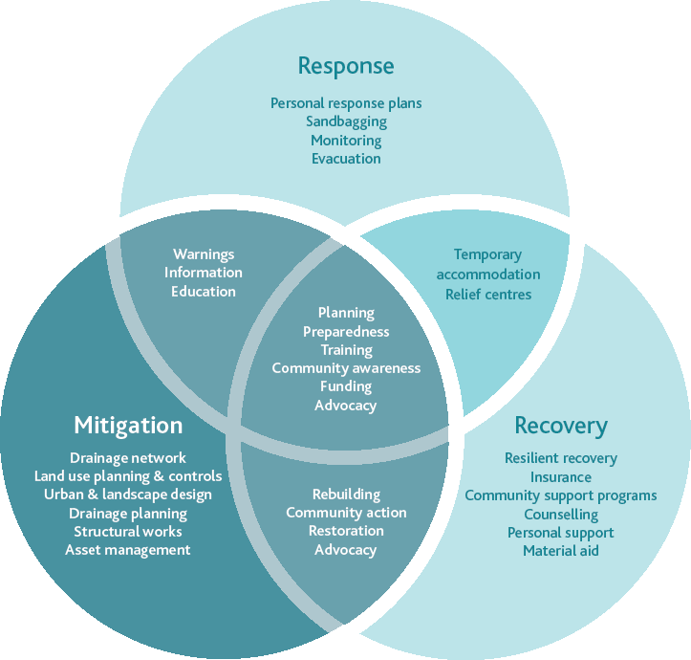
There are many approaches to mitigate flooding and to prepare for inevitable events. The steps involved in flood management include developing our understanding of flooding and the vulnerabilities of people, places and assets.
Effective response and recovery processes are engaged during and after flood events in line with Victoria’s emergency management framework. Finally, we can review our progress and take action to improve.
These steps are incorporated within the objectives and focus areas of this strategy. The steps in the process of flood management are shown in Figure 8.
Figure 8 Stages in flood management – before, during and after
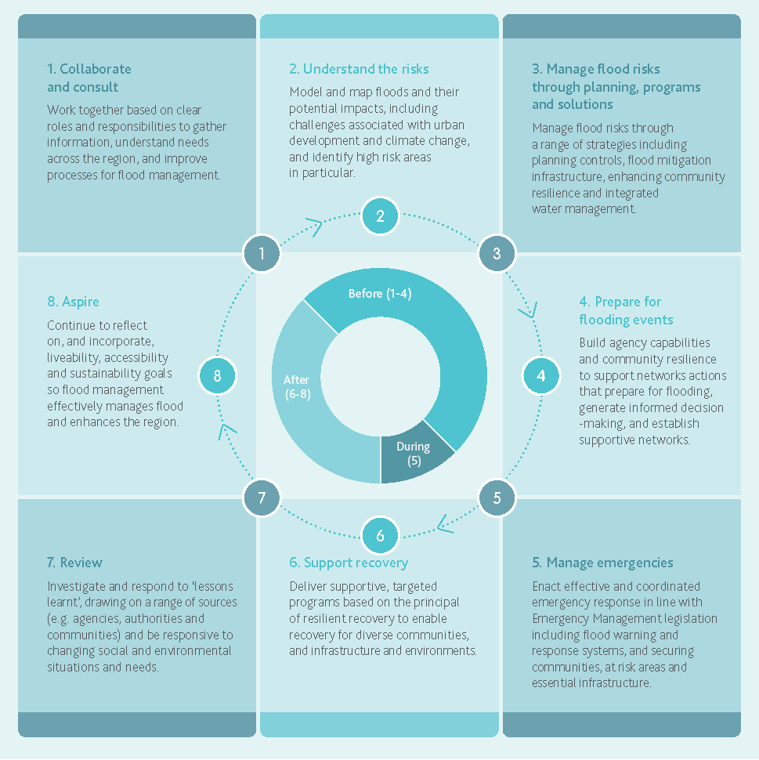
Before flood event:
- Collaborate and consult
Work together based on clear roles and responsibilities to gather information, understand needs across the region, and improve processes for flood management.
- Understand the risks
Model and map floods and their potential impacts, including challenges associated with urban development and climate change, and identify high risk areas in particular.
- Manage flood risks through planning, programs and solutions
Manage flood risks through a range of strategies including planning controls, flood mitigation infrastructure, and integrated water management.
- Prepare for flooding events
Build agency capabilities and community resilience to support actions that prepare for flooding, generate informed decision-making, and establish supportive networks.
During flood event:
- Manage emergencies
Enact effective and coordinated emergency response in line with Emergency Management legislation including flood warning and response systems, and securing communities, at risk areas and essential infrastructure.
After flood event:
- Support recovery
Deliver supportive, targeted programs to enable recovery for diverse communities, infrastructure and environments.
- Review
Investigate and respond to ‘lessons learnt’, drawing on a range of sources (e.g. agencies, authorities and communities) and be responsive to changing social and environmental situations and needs.
- Aspire
Continue to reflect on, and incorporate, liveability, accessibility and sustainability goals so flood management effectively manages flood and enhances the region.

Roles and responsibilities in preparing for and managing flood risk
Many organisations have a role in preparing for and managing flood risk due to the way flooding moves through the landscape – crossing boundaries of responsibility – and because partners have different roles and responsibilities in relation to flood management.

Summary of activities and responsibilities

Melbourne Water (regional drainage and floodplain management authority and waterway manager)
- Coordinates planning and delivery of regional flood management and drainage services
- Undertakes catchment and coastal flood modelling and mapping
- Provides flood advice for new land use and development as a referral authority
- Contributes information to warning services, particularly, manages flood warning hydrographic infrastructure
- Manages regional drainage systems (in the Port Phillip and Westernport region this generally refers to drainage systems servicing a catchment of greater than 60ha)
- Melbourne Water provides coastal inundation advice within the region based upon our Planning for Sea Level Rise guideline
- Manages waterways
- Contributes to development and use of integrated water management knowledge and tools
- Undertakes technical research.

The 38 councils in the region
- Administer and enforce planning schemes, which include state and local flood policies and controls.
- Manage local drainage systems (in our region this generally refers to drainage systems servicing an area of less than 60h)
- Undertake flood modelling and mapping of local drainage systems
- Support local flood planning and coordinate local emergency planning
- Support development of local community resilience
- Implement state and regional strategies through the application of appropriate zones and overlays, and flood management decision-making and activities
- Can develop local water management strategies and plans
- Contribute to development and use of integrated water management knowledge and tools
- Support community recovery from flood events.

Retail water authorities
- Manage urban water supply and sewage services
- Undertake technical research
- Develop and implement integrated water management infrastructure and tools with other stakeholders.

Victorian government departments and agencies
- Set policies, guidelines, standards and strategies for floodplain management, urban planning and development, water resource management, marine and coastal management, and emergency management
- Contribute to development and use of integrated water management knowledge and tools
- Support recovery from floods.

Emergency services agencies
- Lead emergency preparation and response
- Deliver community awareness and education programs
- Provide flood warnings to the community (Emergency Management Victoria)
- Are the designated control agency for floods (Victoria State Emergency Service).

Australian government departments and agencies
- Set national policies and guidelines for flood and emergency management
- Coordinate national research and data on a range of flooding, weather and climate change issues
- Contribute to delivery of warning services
- Contribute funding to flood prevention and recovery activities.

Insurance industry
- Projects and shares the financial consequences and recovery costs.

Communities, individuals and businesses
- Are responsible for understanding personal and local risks, and being prepared for floods
- Can contribute to development of local flood management projects and plans.

Managing the vital drainage system
Different organisations work together to manage the drainage system, which includes our network of regional and local drains, roads and retarding basins. Drainage is crucial infrastructure in flood management; the Port Phillip and Westernport region has an extensive drainage system that protects the majority of the region from regular flooding.
In our region:
- Melbourne Water manages 1,400 kilometres of regional drains
- local councils manage 25,000 kilometres of local drains and street gutters
- property owners are responsible for their residential roof gutters, downpipes and pipelines
- agencies, such as VicRoads and VicTrack, manage other drains.
As Melbourne grows, we are extending the drainage system to protect these new areas from regular flooding. We continue to maintain and optimise existing drainage infrastructure in line with the changing circumstances including consideration of climate change, urbanisation and community values.

Policies and strategies influencing flood management
This strategy sits within a framework of related policies and strategies that work together to help enhance community safety, prevent and manage flooding, and support response and recovery (See Figure 9).
These policies and strategies operate at different levels and focus on different topics, but all link to aspects of delivery of this strategy.
We recognise this policy context and in this strategy we aim to complement and build on the objectives and purpose of these documents rather than replicate them. The primary policy basis for this strategy is the Victorian Flood Management Strategy, which requires the development of regional flood management strategies (Accountability 26a) and the Water Act 1989 which requires the development and implementation of the strategy (Section 202(2)(d).
Figure 9 Flood management and related policies and strategies
Policy/Strategy | State | Regional | Local
Climate Adaptation  Climate Change Act 2017 | - Victorian Climate Change Adaptation Plan (future plans are statutory requirements) | - Resilient Melbourne (Strategy) | - Climate Adaptation Plan (Local)  - Resilience Plan
Coastal Management  Marine and Coastal Act 2018 | - Marine and Coastal Policy (statutory requirement)  - Marine and Coastal Strategy (pending) (statutory requirement) | - Regional and Strategic Partnerships (statutory requirement) | - Coastal and Marine Management Plan (statutory requirement)  - Coastal Management Plan
Environment  Environment Protection Act 1970/2017 | - State Environment Protection policy (Waters) (statutory requirement) | - Port Phillip Bay Environmental Management Plan 2017 to 2027 (statutory requirement) | - Environment Sustainability Plan
Land Use Planning  Planning and Environment Act 1987 | - Victoria Planning Provisions (statutory requirement) (& Planning Policy Framework) for State, Regional & Local | - Plan Melbourne | - Planning scheme (statutory requirement)  (& Municipal Planning Strategy)  - Precinct Structure Plans (statutory requirement)  - Environmental Sustainable Design Assessment (statutory requirement)
Water Management  Water Act 1989 | - Water for Victoria  - Integrated Water Management Framework for Victoria  - Victorian Waterway Management Strategy | - Regional Integrated Water Management Forums & Strategic Direction Statements  - Healthy Waterways Strategy (statutory requirement)  - Yarra Strategic Plan (draft) (statutory requirement)  - Central Region Sustainable Water Strategy (statutory requirement) | - Integrated Water Management (or Water Sensitive Urban Design) Plan (statutory requirement)  - Stormwater Management Plan (statutory requirement) (under SEPP (waters))
Floodplain Management  Water Act 1989 | - Victorian Floodplain Management Strategy | - Flood Management Strategy – Port Phillip and Westernport (required under VFMS) | - Drainage Asset Management Plan  - Flood Management Plan (local)
Emergency Management  Emergency Management Act 2013 | - State Emergency Response (statutory requirement)  - State Emergency  - Management Sub-Plans | - Regional emergency Management Plan  - Central Region Emergency Response Plan – Flood Sub Plan | - Municipal Emergency Management Plan (statutory requirement)  (& Flood Emergency Plan) (statutory requirement)  - Victorian State Emergency Service Local Flood Guides

What we have achieved since the last flood strategy
Melbourne Water released its first Flood Management Strategy Port Phillip and Westernport in 2007. This strategy focused on addressing severe and intolerable flooding and drove significant investment in building infrastructure to reduce flooding in the region. This strategy also resulted in the introduction of local flood management plans, which enhanced the collaboration between Melbourne Water, councils and Victoria State Emergency Service to address local flooding challenges.
In 2015, Melbourne Water released the first collaborative Flood Management Strategy Port Phillip and Westernport, which was built with input from 49 partners, including all 38 councils in the region. This strategy moved from setting a Melbourne Water direction to a regional direction, recognising the benefit of greater collaboration between the various partners across the region.
Whole-of-catchment mapping, in which council and Melbourne Water undertake mapping together, is now standard practice.
Flood management plans with councils are continually updated and used to drive collaboration, and new collaborative approaches such as the Elster Creek Collaboration Committee have been trialled. Integrated services plans between Melbourne Water and councils include a focus on aligning maintenance and operations to ensure the drainage system functions as effectively as possible.
The achievements in Figure 10 are a selection of the great work with our partners that has been achieved to date since the 2015 to 2021 strategy.
Figure 10 A selection of flood management strategy achievements
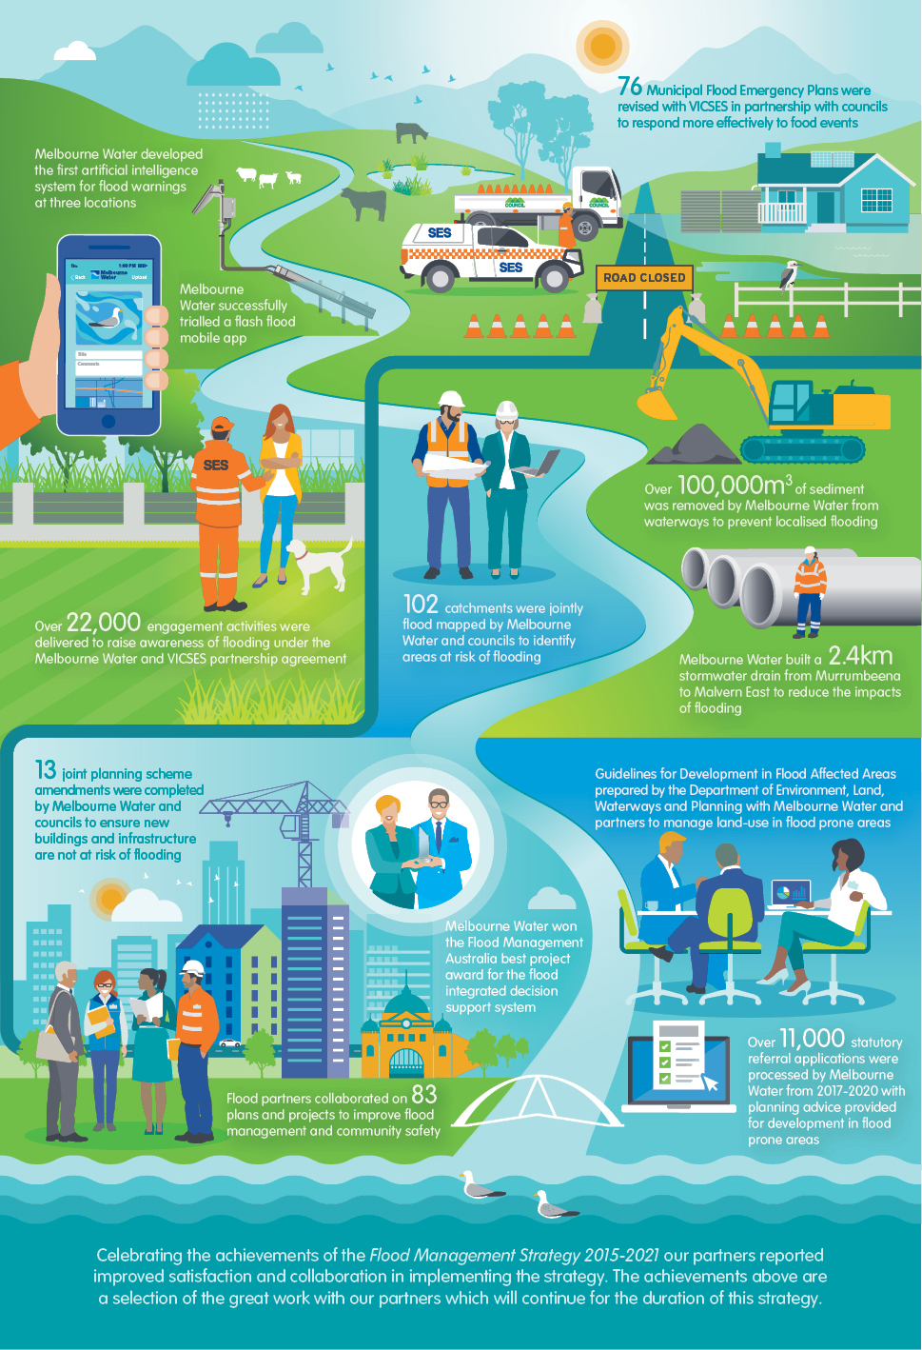
Achievements:
- 3 flood warning systems developed by Melbourne Water are now leading state and national standards
- Successful trial of a flash flood mobile app
- Over 12,000 households received flood education and awareness under the Melbourne Water and Victoria State Emergency Service partnership
- 13 joint planning scheme amendments completed by Melbourne Water and Councils to ensure new buildings and infrastructure are not at risk of flooding
- Flood partners collaborated on 70 plans and projects to improve flood management and community safety
- 63 Flood Emergency Management Plans revised by Victoria State Emergency Service in partnership with Councils to respond more effectively to flood events
- Over 100,000m3 of sediment removed from waterways to prevent localised flooding across the region
- 54 catchments jointly flood mapped by Melbourne Water and Councils to identify areas at risk of flooding
- A 2.4 km stormwater drain with a 1.8m diameter was built from Murrumbeena to Malvern East to reduce the impact of flooding for residential homes.
- Guidelines for Development in Flood Affected Areas prepared by the Department of Environment, Land, Waterways and Planning with Melbourne Water and partners to manage land-use in flood prone areas
- Awarded the Flood Management Australia best project for the Flood Integrated Decision Support System
- Over 11,000 statutory referral applications processed from 2017 to 2020 with planning advice provided for development in flood prone areas.
- Celebrating the achievements of the Flood Management Strategy 2015 to 2021 our partners reported improved satisfaction and collaboration in implementing the strategy. The achievements above are a selection of the great work with our partners which will continue for the duration of this strategy.
Case study: Collaborative approaches
Elster Creek Catchment Action Plan
The Elster Creek Catchment has a number of complexities including increasing in-fill development, flat topography, limited open space opportunities for flood mitigation, sea level rise and competing community drivers – meaning flood management requires significant collaboration, planning and investment.
In 2017, the chief executive officers of the cities of Port Phillip, Glen Eira, Bayside, and Kingston, together with Melbourne Water, entered into a memorandum of understanding (MOU) to plan for and manage flooding within the Elster Creek catchment at a whole-of-catchment level. The memorandum of understanding sets out core principles that affirm everyone involved will collaborate to find evidence-based, innovative solutions that most benefit the community in the catchment’s region. The councils engaged with local community members to develop a common understanding of effective ways to address flooding problems.
The Elster Creek Catchment Flood Management Plan 2019–2024 was endorsed in October 2019 and provides a five-year program of work that builds on outcomes from the previous action plan to reduce flood risks across the catchment. It was developed in consultation with the community and councils and recognises that flood risk reduction requires a range of levels of intervention to be successful. It includes three key focus areas that ensure a holistic approach to flood planning in the catchment:
- on-ground solutions that minimise flooding and its impact on the community
- land-use planning that seeks to minimise urban run-off and reduce flood risk
- community engagement that ensures the community is informed and well-prepared.
A project working group, consisting of representatives from each organisation, is progressively implementing actions in the flood management plan.
Case study: Mapping and modelling floods
Collaborative flood mapping
The City of Glen Eira experiences significant and damaging flooding. Large flood events in February 2011 and December 2016, for example, resulted in widespread above-floor flooding of properties.
In 2018, Glen Eira City Council expanded its flood modelling program, collaborating with Melbourne Water to compare and authenticate council and Melbourne Water flood models. The result was updated and peer-reviewed flood mapping for all drainage catchments in the municipality.
The next phase will involve updating the proposed Melbourne Water special building overlay (SBO1) as an amendment in the planning scheme and introducing a new council special building overlay (SBO2). Each overlay identifies areas prone to overland flooding under council or Melbourne Water control, and sets appropriate conditions and floor levels to address any flood risk to new developments.
Glen Eira City Council has used local flood mapping over the last three years to inform building and development. Under the Building Regulations 2018, the council issues a flood level report if an allotment is prone to major flooding. The council recommends that a property owner and/or developer obtain this report before starting design work.
Case study: Murrumbeena to Malvern flood mitigation
Flood mitigation
Melbourne Water initiated the Murrumbeena to Malvern Flood Mitigation Project in 2017 after this area experienced significant flooding in 2006 and 2011. A two kilometre long, 1.8 metre diameter stormwater drain was constructed through residential streets and parks between Railway Parade in Murrumbeena and the Monash Freeway in Malvern East. The new stormwater drain collects water from heavy rainfall that flows over the streets and paved surfaces, reducing the impact of flooding to properties in the area.
An embankment was removed to restore the natural overland flood flow path of the Murrumbeena Creek. Community access to high-quality open spaces were unlocked to the north of the railway line by lowering steep embankment slopes. Removing sections of the grassed embankments also improved natural light to the area, and provided a better link between neighbours and the suburb.
A previously dead-end space was also activated at Riley Reserve, in line with the City of Glen Eira’s open space master plan. A new walking and cycling corridor provides opportunities for active transport within the area. This connects residents of southern Murrumbeena to green spaces and existing trails extending as far as Scotchman’s Creek Trail.
Early engagement with stakeholders, particularly the Level Crossing Removal Project, enabled us to reduce community impact by constructing both projects at the same time. By working with stakeholders we were able to realise a number of additional project and liveability benefits.

A shared vision for Port Phillip and Westernport

The Flood Strategy in Action
To direct our strategy, we have a collective vision, objectives and 10-year outcomes. Our focus areas, which support our objectives, take a holistic approach to flood management, building on our many achievements.

Vision, objectives, 10-year outcomes and focus areas
As partners, our vision ensures we have a shared goal that we are collectively working towards. Our three objectives are essential to achieving our vision. Each objective has 10-year outcomes so we can measure our progress and has focus areas to direct our actions. (See Figure 11).
While this is a 10-year strategy, the vision and objectives extend beyond this timeframe, recognising the ongoing, adaptive approach required.
This 10-year strategy will be underpinned by two five-year collaborative action plans. These enable us to adapt our approach over time as new information, tools and approaches become available.
Figure 11 Vision, objectives, 10-year outcomes, focus areas and five-year Action Plans × 2
This 10-year strategy will be underpinned by two 5-year collaborative Action Plans. These enable us to adapt our approach over time as new information, tools and approaches become available.
Vision
Together we are aware, responsive and resilient. Communities, business and government understand flooding, plan collaboratively for challenges and take action to manage risks and optimise opportunities, for now and the future.
Objective 1: The right information is available at the right time to the people who need it
- 10-year outcomes
  - Agency knowledge of flood risks has improved
  - Communities in flood prone areas have increased awareness of flood risk
  - Flood affected communities have access to clear, appropriate and timely emergency information
- Focus areas
  - Fit-for-purpose information
  - Empowering communities
- 5-year Action Plans × 2
  - Actions
Objective 2: Flood risks and opportunities are managed to reduce impacts and get the best social, economic and environmental outcomes
- 10-year outcomes
  - Flood impacts are reduced (relative to a do-nothing scenario)
  - Land use and development in flood prone areas is appropriate to the level of flood risk
  - The impacts of climate change and coastal flooding are incorporated into planning and decision making
  - Integrated Water Management and flood infrastructure achieve maximum public value
- Focus areas
  - Flood effects mitigation
  - Land use planning
  - Challenges of climate change
  - Multiple benefits embedded in decision-making
- 5-year Action Plans × 2
  - Actions
Objective 3: Land, water and emergency agencies work together to manage flooding effectively
- 10-year outcomes
  - Clear roles and responsibilities allow agencies to deliver effective flood management and emergency services
  - Agencies collaborate to plan for and manage flood risk and flood emergencies (our collaborative approach to delivering this strategy will help deliver this outcome.)
- Focus areas
  - Clarifying roles and responsibilities
  - Emergency agency preparedness and response
  - Flood recovery
- 5-year Action Plans × 2
  - Actions

The focus areas
We have developed nine focus areas to build on our current approaches to flood management. There is so much to do to manage flooding.
These focus areas direct our attention to the main priorities to achieve each 10-year objective.
The focus areas are based on the fundamental activities required to reduce flood risk and on the key directions: managing climate change, empowering diverse communities, and managing flooding to achieve multiple benefits. Our partners identified these key directions – always with an approach of collaboration, responsibility and accountability.

About the focus areas
The focus areas drive targeted, additional effort in flood management based on a clear rationale to reduce flood risk. The focus areas ensure effort is directed towards the specific actions in the initial five-year action plan.
Detailed descriptions of each focus area follow. You will also see in this section where we want to be in 10-years in relation to each of the focus areas.
Our need for flood information underpins the entire strategy, with direct input into essential functions such as land use planning, flood effects mitigation and emergency response. To reduce flood risk, we must first understand it.
Objective One: The right information is available at the right time to the people who need it
The first step to managing flood risk is to understand where floods could happen and what the impacts could be. Different aspects of flood management require different information and flood management agencies need to access it easily. The community also needs to be able to access relevant flood information. Making clear flood risk information easily accessible to people and businesses enables them to understand their risk, and to be prepared to take action before, during and after a flood event.

Focus Area 1: Fit-for-purpose information
Where will we be in 10-years?
The purpose of the information we generate is clearly identified and understood. All agencies work together to generate fit-for-purpose information to agreed standards. We share this information effectively between agencies. Flood information for high-priority areas is no older than 10-years.

Why do we need fit-for-purpose information?
We need fit-for-purpose flood information to quantify flood risk and use it to inform decisions about the way we best manage and reduce flood risk.
Flood information is used in many ways:
- planning
  - statutory processes such as including flood maps in planning schemes
  - urban growth planning processes such as developer services schemes for greenfield areas and major redevelopments, so flood risk is addressed in development.
- emergency management
  - collaborative development of local flood management and flood emergency plans
  - emergency planning processes
  - flood warning systems to provide advance warning of flooding.
- insurance
  - up-to-date information, which helps insurance companies to understand current flood risks as well as any mitigation measures introduced by local authorities to reduce flood exposure, enables insurance premiums that better reflect the flood risk as determined by authorities.
- asset management and design
  - identifying and prioritising where intervention is needed
  - asset data information sharing between drainage and infrastructure managers
  - project-based information sharing to inform project design.
- land and property owners
  - development advice to landowners and planning permit referrals
  - specific flood information for property owners related to their property.

Flood mapping and modelling
Flood mapping and modelling are a crucial part of creating flood information and we have made significant progress. Flood mapping has already been undertaken for most waterways and drainage systems managed by Melbourne Water, and along some drainage systems managed by councils. The Department of Environment, Land, Water and Planning’s (DELWP) Future Coasts program has undertaken high-level mapping of coastal flood risks from storm tides and future sea level rise for all the Port Phillip Bay and Western Port coastlines. Melbourne Water managed a coastal hazard risk assessment for Western Port in 2015. In 2020-21, Department of Environment, Land, Water and Planning are undertaking a similar hazard assessment of coastal inundation, coastal erosion and groundwater intrusion in Port Phillip Bay.

What are the challenges for flood mapping and modelling?
Flood models and associated mapping are complex. They take time as they process significant amounts of information, and it is challenging to keep the information up-to-date in a complex and ever-evolving environment. Flood information can be developed at a range of scales and, as the scale becomes more localised, a finer level of accuracy and completeness is required, which becomes increasingly more complex and resource-intensive. Flood information needs to be fit-for-purpose and the information needs to be efficiently incorporated into decision-making and, particularly, the planning scheme.

What will we do?
Melbourne Water will lead an escalation of the regional flood modelling program, with appropriate resourcing. The focus of the program is to keep mapping information for each catchment current and fit-for-purpose, using the best-available data. Local councils will be key partners in this program to implement a whole-of-catchment mapping approach.
Flood modelling and mapping will incorporate best practice climate change information and techniques with regard to rainfall and runoff, coastal flooding and sea level rise. The purpose is to understand flood risk to people, property and the environment, and the effects of mitigation responses.
We will:
- strengthen our flood modelling program to ensure we have appropriate flood information available to provide planning and development advice
- define and articulate clear flood information standards and processes to ensure the development and generation of flood information is current, consistent and fit-for-purpose
- align organisations’ flood modelling work to ensure the most up-to-date information is available to the people and organisations that need it
- run capacity building programs to support partners in their flood modelling and mapping actions
To achieve this, Melbourne Water and councils will work with modelling and mapping providers.

Focus Area 2: Empowering communities
Where will we be in 10-years?
There is a tailored and effective community awareness and preparedness program. As a result, at-risk communities understand the risks and opportunities and are more prepared to take action and make informed choices. An ongoing regional campaign is in place, and it is improving general community awareness about flood impacts and safety.

What are empowered communities?
Communities involve individuals, groups and businesses.
Empowered communities are ‘flood ready’. Flood ready communities are aware of their level of flood risk, can take steps to prepare for flooding, and understand what to do when warnings are issued. They are likely to experience less loss, damage, stress and disruption, and recover faster when flood events occur.
Communities are diverse. Different parts of the community require information tailored to their needs; for example, renters and non-renters, younger and older age groups, and various preferred languages, all require different information or information presented in a different way.
Flood risk varies across the region based on geography, therefore education and awareness programs need to provide general flood awareness to communities at lower risk, and more specific local information in flood prone or high-risk areas.
An aware, enabled community is able to help ensure the efficient and consistent implementation of agency emergency response plans, helping to reduce the overall impacts of flood events.

How do we empower communities?
Community awareness of flooding has not increased significantly since 2015.
The Flood Risk Awareness 2018 report commissioned by Melbourne Water and Victoria State Emergency Service found that:
- Only 44% of households in flood prone areas were aware of their flood risk.
- Only 34% were prepared for flooding.
We empower communities by giving them the information they need to make informed decisions and to prepare for flood events. Programs will be developed based on community engagement and research into ways to engage effectively with communities to build awareness and resilience to flooding.
A range of actions that support empowered communities include:
- awareness and education: timely flood warnings and awareness of, and education about, flooding and the associated risks, including current risks and future risks from climate change
- preparedness: developing personal response plans, particularly in high-risk areas, and encouraging proactive redevelopment where risks can be mitigated through design
- response: responding to keep themselves, their communities and animals safe during a flood, including knowing what to do and how to access reliable information and support
- recovery: developing lasting resilience including appropriate insurance and how to access community and personal support.
We are required by law to consult communities when changes are made to the planning scheme. We are committed to effective and early engagement as we update modelling to discuss the impacts and how to keep people safe.
Effective flood warnings are critical. The Bureau of Meteorology (BoM), Melbourne Water, Victoria State Emergency Service and Emergency Management Victoria (EMV) coordinate to issue flood warnings in line with state and federal standards and guidelines. Riverine flood warnings are well established and effective. We recognise that flash flooding is more complex given the highly localised and rapid onset of flooding. We are reviewing the potential of new technology to develop efficient and effective early warning systems. Specific planning is required for coastal flooding and storm surge events in the region.
Key information for communities includes:
- accessible maps that show the extent of flooding in the region
- local flood guides for residents and business owners
- information on how to prepare for a flood
- information on future flooding risks related to climate change including increased rainfall intensity, sea level rise and coastal flooding.
Communities need information that is easy to access and is relevant to their situation. We need to understand our communities and their needs and provide targeted information.

What will we do?

Develop a community capacity building strategy
We will develop a clear community strategy for capacity building including agreed roles and responsibilities for program delivery.

Deliver community awareness and capacity building programs
We will deliver tailored programs to communities with the highest risk of flooding, as well as a broad community awareness program. The programs will aim to build resilience to, and awareness of, risks and promote protective action.
Continue flood warnings – flash flooding and storm surge We will continue and improve flash flooding and storm surge warnings. We will monitor the stormwater pipe network in high-priority areas. We will develop automated flash-flood warnings for high-priority areas and incorporate them into existing community warnings systems. During a significant event, there will be warnings to the community from the control agency or the incident response controller.

Continue flood warnings – riverine
Riverine flood warnings are well established along the major waterways in the region. During a significant event, relevant agencies will continue to work together to deliver warnings to the community. Additional expansion of the network will be undertaken, as appropriate, throughout the life of the strategy.

Develop a community knowledge platform
A community knowledge platform is a new, ambitious initiative that is not currently the responsibility of, or funded by, any agency. Melbourne Water and Victoria State Emergency Service will lead the development of the platform with the support of our partners. Melbourne Water and Victoria State Emergency Service will start this program by undertaking research and development and preparing a business case.
Upon approval, we will develop a platform that provides the community with the information they need to prepare, respond and recover effectively from floods.
The platform will:
- provide guidance on what to do before, during and after flooding
- include information on localised flood risk and the impacts of climate change
- be kept up-to-date with new information as it becomes available and be regularly reviewed by its primary and secondary audiences to maximise effectiveness
- not include flood warnings. Warnings will continue to be provided by Emergency Management Victoria via their established community warning channels.

Support capacity building for partners
We will run capacity building programs for partners to support effective and consistent community engagement across the region.
Objective Two
Flood risks and opportunities are managed to reduce impacts and get the best social, economic and environmental outcomes
Taking action to manage current and future flood risks will require a mix of solutions tailored to each specific location and community. Identifying the best approach for each location requires an understanding of local needs, broader environmental and catchment conditions, possible future risks, and the lifecycle costs and additional benefits (or drawbacks) of each potential flood management solution. This information is used to develop the best-fit solution for each location.

Focus Area 3: Flood effects mitigation
Where will we be in 10-years?
Through the delivery and maintenance of infrastructure solutions, flood effects are reduced (compared to a do-nothing scenario). Agencies and the community work together to identify the right mix of solutions for each location. We continue to explore innovative solutions and expand our suite of tools to manage flood risks.

How do we reduce the effects of floods?
We have many well-established ways to mitigate the impacts (or ‘effects’) of flooding including our drainage system, which continues to be extended and optimised; flood management infrastructure; and multi-functional assets. We will continue to manage, maintain and renew effective assets.
To respond to the challenges of urbanisation and climate change, we also need to build new assets. We need to develop agreed long-term service standards for assets, which consider their long-term viability in the face of climate change. Local councils represent their communities when locations for flood management are being prioritised. Local communities will be involved in developing potential solutions to flooding problems.
It is essential that we continue to innovate and broaden the suite of tools available for managing flooding. For example, the nature of urbanisation can prohibit and constrain cost-effective opportunities for flood effects reduction. New approaches may include infrastructure, technology, community education or land use planning controls. As our city develops and population density increases, some of our approaches will become more challenging to implement. As new technology becomes available and new approaches to managing flooding are developed nationally and internationally, these should be considered for their suitability to manage flooding in our region. Not all approaches are viable for all situations, which means it is essential we use a broad suite.
So that we make best use of limited public funds, it is critical that we think strategically across the whole catchment. We need to consider flooding, stormwater and drainage functions together. We need to incorporate green infrastructure such as wetlands, replace hard surfaces with vegetation, and direct water to support useable green space for urban greening and cooling – for multiple benefits.
The design of flood assets can also help to build community awareness that the area they are in is subject to flooding.
Figure 12 Making best use of resources – choosing the right approach in each location
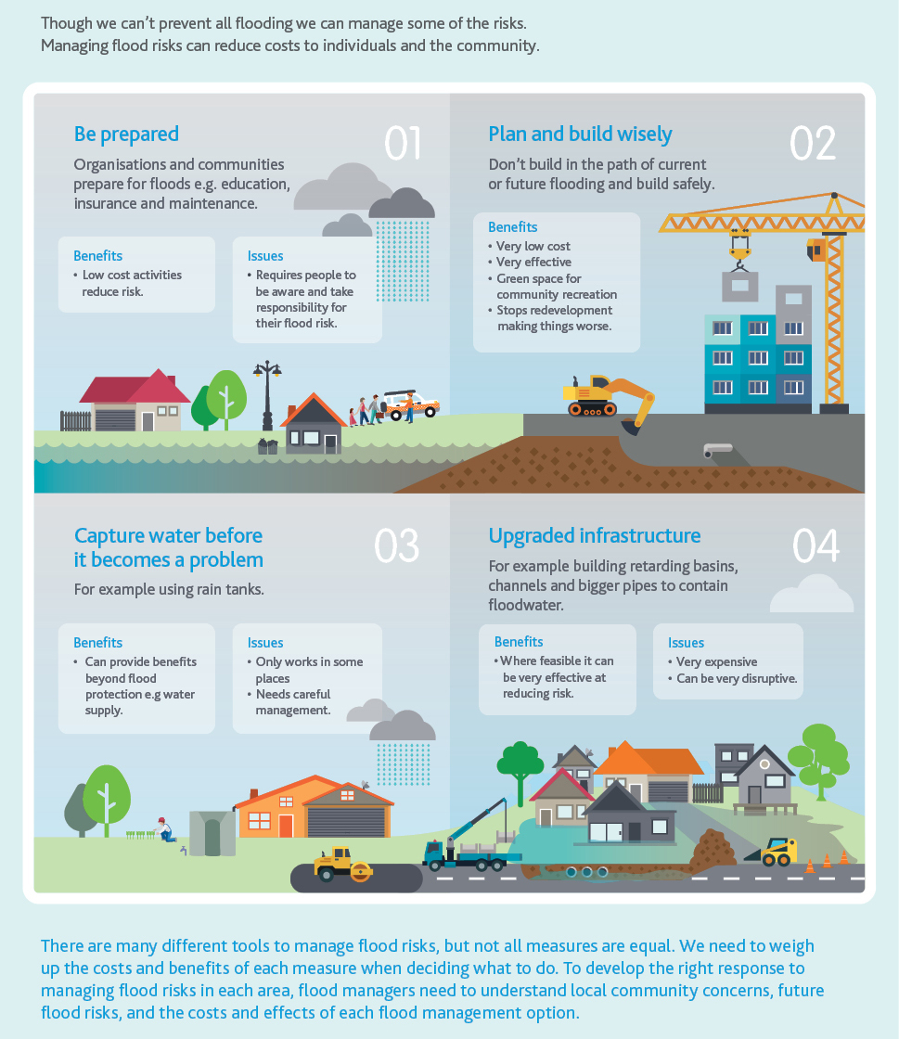
Though we can’t prevent all flooding we can manage some of the risks. Managing flood risks can reduce costs to individuals and the community.
- Be prepared: organisations and communities prepare for floods e.g. education, insurance and maintenance.
Benefits:
  - Low cost activities reduce risk
Issues:
  - Requires people to be aware and take responsibility for their flood risk.
- Plan and build wisely: don’t build in the path of current or future flooding and build safely.
Benefits:
  - Very low cost
  - Very effective
  - Green space for community recreation
  - Stops redevelopment making things worse.
- Capture water before it becomes a problem: for example using rain tanks.
Benefits:
  - Can provide benefits beyond flood protection e.g water supply
Issues:
  - Only works in some places
  - Needs careful management
- Upgraded infrastructure: for example building retarding basins, channels and bigger pipes to contain floodwater.
Benefits:
  - Where feasible it can be very effective at reducing risk
Issues:
  - Very expensive
  - Can be very disruptive
There are many different tools to manage flood risks, but not all measures are equal. We need to weigh up the costs and benefits of each measure when deciding what to do. To develop the right response to managing flood risks in each area, flood managers need to understand local community concerns, future flood risks, and the costs and effects of each flood management option.

What will we do?

Prioritise
We need to continue to refine our approach to identifying high-priority areas and investigate these areas to identify flood mitigation options.

Deliver infrastructure
We will continue to investigate asset solutions and deliver feasible flood mitigation infrastructure. We will also investigate approaches that broaden our suite of tools. Once we have agreed on high-priority areas for exploration, we will work with local communities to develop the actions that need to occur.

Maintain
We will develop and deliver infrastructure maintenance programs according to our agreed levels of service. The Melbourne Urban Stormwater Institutional Arrangements (MUSIA) project will clarify roles and responsibilities for stormwater management, including maintenance.

Innovate
Being innovative is an important part of our strategic approach to broaden our suite of tools available for flood management. We will identify new opportunities and innovations and assess their feasibility. We will pilot place-based solutions and adopt successful solutions as ‘business-as-usual’.
There are many innovative ideas to explore. For example, partners across the region may explore an approach in a flood-prone catchment to mitigate flood effects through distributed storages. These distributed storages – rainwater tanks or other types of decentralised water storage systems – can offer value in certain types of catchments by reducing the extent of runoff, therefore decreasing the impacts of flooding downstream within the catchment. Other benefits include lower water bills, reduced demand on drinking water supplies, greener gardens as well as reduced stormwater runoff and healthier waterways.
Another opportunity is to identify approaches to design or retrofit homes to ensure they are more flood resilient.
Home owners at high risk of flooding can incorporate design features into their building to ensure it is able to better withstand a flood event when it occurs. Information will be available to help home owners reduce the impact of flooding.

Focus Area 4: Land use planning
Where will we be in 10-years?
Planning decisions are based on best available information about future conditions including sea level rise and increased rainfall intensity from climate change. Planning schemes updates are expedited to incorporate new flood information when it is available. Planning controls have been introduced to reduce downstream catchment flooding. More nuanced approaches are used to consider flood risks determining the types of land uses and development allowed in flood prone areas. Land use planning will respond proactively to flood risk.

What are the challenges associated with land use planning?
The land use planning system involves a range of policy instruments including legislation, regulation, policy, strategic planning, guidelines and standards to guide and manage land use and development. Partners use these instruments, relevant to their roles and responsibilities.
In most cases, councils administer the planning scheme for their municipality.
We have significant challenges for land use planning in the current context.
- Melbourne Water and councils regularly map flood extents of waterways and major drainage systems; however, the process of incorporating maps into the planning scheme takes a long time.
- Extensive urban development is occurring in response to population growth and we need to continue to set standards, guidelines and build capacity for partners to best mitigate against flooding for new developments and downstream.
- When planning for the impacts of flooding, climate change needs to be comprehensively considered in the planning system, and consistently applied across councils.
- While the current approach to land use planning identifies risk and guides development accordingly, there is an opportunity to take a more nuanced approach to considering the types of development and land use that take place in certain locations based on the risk (depth and speed of flooding).
- There is an opportunity to direct more attention to upstream influences on flooding to reduce the impacts downstream, as a holistic approach to flood management. A whole-of-catchment approach recognises the intricacies of water flow and management across municipal boundaries.

What will we do?

Streamline the approach to amendments
We will work to expedite the approach to planning scheme amendments for flood controls, to ensure flood mapping can be more readily incorporated into the planning system. This will include looking at the opportunity to engage with community earlier in the amendment process in relation to the flood mapping. We will actively support councils in engaging with affected parts of the community.

Include climate change in relevant planning controls
We will adopt the Australian Rainfall and Runoff Guidance as best practice to map, model and understand the flood risk associated with the increased intensity of rainfall.
We will apply best practice climate change flood modelling in all future flood-related planning scheme amendments and emerging greenfield development schemes.

Enhance our risk-based approach
We will explore opportunities for new approaches through effective strategic planning so that planning schemes guide land uses and development to appropriate locations on the basis of flood risk.

Explore upstream planning controls
We will explore the introduction of planning controls to a catchment or specific area, or other measures, to reduce upstream runoff by increasing stormwater capture and/or permeability targets to reduce downstream flood risk.

Support better design outcomes
We will explore options to support better design outcomes in flood prone areas that will meet architectural and urban design, integrated water management, and flood management and mitigation outcomes. We will review guidelines and support updates to the Victorian Planning Provisions. Floor levels will be met in all locations.

Support planning decisions
We will prepare a regional statutory decision guideline that adopts best practice integrated water management and flood management.

Focus Area 5: Challenges of climate change
Where will we be in 10-years?
We understand the likely range of climate change impacts and costs on flooding in the region. Climate change is incorporated into all new mapping and modelling. Our best available knowledge is embedded in flood management decision making including land use planning and flood infrastructure. Climate change knowledge is shared with partners and the community. Adaptive approaches are understood and we have tools to consider climate change in identifying locally specific solutions.

What are the gaps in our progress in acting on climate change?
We have made significant progress towards acting on climate change. This work is a strong foundation; however, there are still gaps.
We need more information about how flooding in our region will be impacted by climate change. We need hazard and vulnerability assessments for riverine and drainage (flash) flooding, and to understand how extreme rainfall events may affect the region. The Victorian Floodplain Management Strategy 2016 states that climate change scenarios should be included in flood studies.
We also need to acknowledge that the effects of climate change are not known with certainty, and that the projections will continually improve over time. In line with the precautionary principle in state legislation, and specifically the Climate Change Act 2017, we cannot let this lack of certainty be an excuse for inaction and we need to continue to work with the best available information.
Where we do have information we need to apply it consistently and promptly, including updating planning schemes with future climate change information.
In 2021, work regarding the Victorian Government’s approach to coastal planning is still evolving. Melbourne Water provides coastal inundation advice within the region based upon our Planning for Sea Level Rise guideline.
The Marine and Coastal Strategy 2021 will set the state-wide direction for coastal management and is supported by a framework for coastal adaptation, namely Victoria’s Resilient Coasts program.
Climate change adaptation requires a shift in thinking. It needs to be considered in flood policy, planning and operations. In addition to building our scientific knowledge base, values and institutional arrangements, a shared commitment is crucial in developing appropriate responses to climate related flood risk.
Flood management will require a range of infrastructure. Infrastructure solutions can be expensive, including property redevelopment and upgrades to drainage systems, roads and bridges, so we need to trial the inclusion of adaptive approaches to ensure they are cost-effective.
Approaches and solutions need to consider a range of climate scenarios. In the long-term, we will need to consider a range of approaches that may reshape the region, from protecting floodplains to retreating from high-risk areas. A focus on choosing no-regret, flexible approaches will ensure they are beneficial under any future scenario. Flood solutions can be developed between partners, and with our community including organisations, businesses and local communities.

What will we do?

Develop our understanding of climate change impacts
We will further develop our understanding of the impacts of climate change including:
- value the cost of annual average damage due to the increased rainfall intensity from climate change
- consider opportunities to use climate change scenarios to support adaptive thinking and action.

Consult, engage and educate
Linked with our community platform and community awareness and preparedness programs, we will engage with communities as follows:
- Consultation: Undertake community consultation to understand community knowledge of the impacts of climate change flood risk.
- Engagement and education: We will deliver shared communication and engagement activities to raise awareness of the increasing flood risk due to climate change, and an education program targeted for at-risk communities.

Develop tools for adaptation projects – place-based and a regional response
We will prepare guidance for Melbourne Water and councils to strategically, efficiently and consistently assess local hazards and vulnerability to enact a consistent approach to climate change adaptation – one that considers the opportunity to combine place-based solutions in catchment-wide planning.

Focus Area 6: Multiple benefits embedded in decision-making
Where will we be in 10-years?
Flood management is recognised as an important element of integrated water management. Flood management solutions achieve multiple benefits to contribute to a city that is safe, cool and walkable, with blue-green corridors and mixed-use spaces, and a city that supports biodiversity and enhanced amenity.

Why do we need to embed multiple benefits in decision-making?
Clean, available water and green space are fundamental to liveability in the region. Population growth, urbanisation and climate change threaten liveability by limiting the extent and quality of green space, and reducing water supply. We experienced these threats and their severity through the Millennium drought.
Flood management and drainage infrastructure and assets are costly to build and maintain, and are complex, particularly in dense urban environments. Traditionally, we have built flood management solutions for the single purpose of reducing flood risk. Thinking about stormwater capture and management to deliver multiple benefits such as flood management, waterway protection, reduced reliance on mains water and cooling and greening our environment will allow us to achieve better outcomes for our community and greater value for money.

How can we achieve multiple benefits through infrastructure?
We can achieve multiple benefits in two key ways.
- Flood infrastructure and assets can deliver a range of benefits to people and the environment. For example, we can increase public access to flood retarding basins to provide people with necessary green refuges for health and recreation, particularly as our climate gets hotter and drier.
- Stormwater and open space infrastructure and assets can be designed to reduce flood risks. For example, stormwater management solutions can capture, infiltrate and direct water to assets such as parks and away from floods. Open space infrastructure can also have multiple purposes. Places such as parks and ovals can retain floodwater during extreme weather events, and then these places slowly infiltrate the water.
We have experience in delivering specific projects that achieve multiple benefits. Councils and the water sector have implemented stormwater projects to maintain green spaces, cool urban environments, and increase water security.
It is critical to understand the local flood context when designing infrastructure and assets. Inappropriate responses that alter flood regimes can exacerbate flooding.

What will we do?
We are taking a systematic approach in the way we consider multiple benefits in flood management. We need to review relevant policies, strategies, guidelines, codes, standards and frameworks. We will develop infrastructure projects that achieve multiple benefits based on high-priority areas, established processes, and innovative solutions, where appropriate. Solutions will be fit-for-purpose and consider the principles of:
- operating at multiple scales for example large infrastructure right through to small scale on lot solutions
- employing different types of approaches such as tanks, detention and retention and distributed storage systems, which provide multiple benefits.

Create an enabling strategic environment
We will determine the level of risk that is acceptable to partners who are responsible for infrastructure and assets, particularly in flood-affected areas. For example, there may be risks to the public from using retarding basins as public open space. We will develop a collaborative process and principles to support the development of projects that achieve multiple benefits. We will review policies, so they consistently enable us to consider multiple benefits in decision-making.

Pilot innovative solutions in new precincts and embed into processes
We will pilot innovative flood management solutions in new precincts (for example Fisherman’s Bend) and use this experience to review and update standards, codes, strategies and guidelines where appropriate so that innovative, place-based approaches – delivering multiple benefits – become business-as-usual.

Incorporate flood mitigation into stormwater projects and processes
We will deliver stormwater projects that deliver multiple benefits including mitigating flood risks. To do this, we will identify high-priority catchments where delivering integrated water management will bring multiple benefits and develop projects through existing forums, partnerships, grants and major projects.

Review land use and water planning process for greenfield developments
We will identify available opportunities to integrate integrated water management and other strategic benefits within existing frameworks in greenfield developments.

Incorporate integrated water management, open space and amenity opportunities into flood infrastructure
We will identify high-priority areas for integrated projects by overlaying flood mitigation and stormwater, waterway and amenity priority areas. We will then identify new and existing flood management infrastructure with the potential to achieve multiple benefit outcomes. By making integrated projects a priority, we will deliver flood management infrastructure and assets that achieve multiple benefits in high-priority locations.
Objective Three
Land, water and emergency agencies work together to manage flooding effectively
As a large number of organisations influence flood management in Port Phillip and Westernport, cooperation and collaboration between agencies is crucial. Aligning and coordinating the delivery of flood management actions will lead to more effective and efficient outcomes for the community.
This objective will be met both with delivering actions under the following three focus areas (numbers 7–9), and through the coordinated approach we take to delivering this strategy.

Focus Area 7: Clarifying roles and responsibilities
Where will we be in 10-years?
The Melbourne Urban Stormwater Institutional Arrangements Review (MUSIA) review is complete and its outcomes are being implemented. Councils and Melbourne Water have clearly defined roles and responsibilities when it comes to flood and stormwater management, and are working effectively together to deliver the best community outcomes.

Why do we need to clarify roles and responsibilities?
Melbourne Water and 38 councils jointly manage stormwater and drainage assets and services in our region.
Stormwater, drainage and flood management activities need to deliver a number of outcomes to meet the needs of the community and the environment, including the delivery of improved water quality, amenity and flood mitigation.
However, the institutional arrangements around flood, drainage and stormwater management were established over 90 years ago.
There have been significant changes since then:
- The extent of assets and services has significantly increased.
- The drivers of liveability, amenity, stormwater as a resource, and healthy waterways and bays have expanded our drainage needs.
- Climate change has and will continue to result in changes to rainfall patterns and sea level rise.
- Population growth, urban land use and climate change bring more severe flooding if not managed appropriately.
- Governance involves an increasing number and interconnection of water management objectives.
- Equitable levels of service and clear lines of support are needed for customers when they experience concerns and issues.
We need to review the institutional arrangements to meet the needs of the growing city and its inhabitants and communities into the future.
Melbourne Water and councils have sought new institutional arrangements and increased clarity about water-related functions and roles to support effective coordination.

The Melbourne Urban Stormwater Institutional project
Department of Environment, Land, Water and Planning is leading a review of the arrangements known as the ‘Melbourne Urban Stormwater Institutional
Arrangements’ (Melbourne Urban Stormwater Institutional Arrangements) project. Melbourne Water and the Municipal Association of Victoria (MAV) (on behalf of councils) are partners in the project and stakeholders are being engaged throughout.
The review covers the catchment thresholds, roles and responsibilities, governance and funding arrangements of stormwater assets and services delivered by Melbourne Water and councils in the Port Phillip and Westernport region.

What will we do?
We will complete the Melbourne Urban Stormwater Institutional Arrangements review and implement new arrangements as a result of the review.
The review of these institutional arrangements, alongside a suite of state stormwater policy reforms and catchment-scale initiatives, offers a unique opportunity to provide for future needs of the community and address legacy issues surrounding existing assets and services.

Focus Area 8: Emergency agency preparedness and response
Where will we be in 10-years?
Agencies with emergency management responsibilities, as outlined in the State Emergency Management Plan (SEMP), will work towards enhanced response capability and capacity that reflect changing flood risks for the community. Emergency preparedness and response approaches are community focused with emphasis on communities at higher risk.
What does emergency preparedness and response involve? Emergency management is governed by national and state legislation, policy and guidelines. Key legislation includes:
- Emergency Management Act 2013
- Emergency Management Legislation Amendment Act 2018
- Victoria State Emergency Service Act 2005
- Victorian Floodplain Management Strategy 2016.
Emergency management requires clear roles, responsibilities and accountabilities to plan and prepare for, respond to, and recover from different types of flooding. Under Victorian emergency management legislation, responsibility for municipal-level emergency planning sits with the multi-agency Municipal Emergency Management Planning Committee (MEMPC), with regional-level emergency planning the responsibility of the Regional Emergency Management Planning Committee (REMPC).
Multi-agency Regional Emergency Management Planning Committees produce a Regional Emergency Management Plan (REMP) that focuses on the consequences of emergencies within their geographical footprint. Each Regional Emergency Management Plan must include content that is specific to that region, without duplicating the SEMP. Responsibility for municipal tier emergency management planning sits with the multi-agency Municipal Emergency Management Planning Committee. The Municipal Emergency Management Planning Committee must prepare a Municipal Emergency Management Plan (MEMP) to cover mitigation, response and recovery, and address the roles and responsibilities of agencies in relation to emergency management. Councils will convene and chair the committees, however, planning is a shared responsibility of the Municipal Emergency Management Planning Committee. The Municipal Emergency Management Planning Committee is required to produce a Municipal Emergency Management Plan which addresses their particular circumstances, needs and risks, which may include flooding. There may also be a need for a sub-plan, or complementary plan, related to flooding.
Relevant agencies should inform the development of these sub-plans and the broader Municipal Emergency Management Plan with subject matter expertise, which might include the Victoria State Emergency Service and Melbourne Water as it pertains to flooding.
Plans are approved by the relevant Regional Emergency Management Planning Committee and are intended to be integrated and comprehensive. Councils will convene and chair the committees, however, planning is a shared responsibility of the Municipal Emergency Management Planning Committee. The Municipal Emergency Management Planning Committee is required to produce a Municipal Emergency Management Plan which addresses their particular circumstances, needs and risks, which may include flooding. There may also be a need for a sub-plan, or complementary plan, related to flooding.
Regional and Municipal Emergency Management Planning – Who’s involved?
Regional Emergency Management Planning Committee (REMPC):
Membership of the Regional Emergency Management Planning Committee comprises of a core membership from Victoria State Emergency Service, Emergency Management Victoria, all councils, all state government departments, Victoria Police, Metropolitan Fire Brigade/ Fire Rescue Victoria (Country Fire Authority where relevant), Ambulance Victoria and Australian Red Cross.
Regional committees may include other members relevant to the geographical footprint. All members participate on an equal basis in the new communities.
Municipal Emergency Management Planning Committee (MEMPC):
Membership of the Municipal Emergency Management Planning Committee includes the council, Victoria State Emergency Service, Victoria Police, Fire Rescue Victoria, Ambulance Victoria, Australian Red Cross and the Department of Health. Municipal Emergency Management Planning Committees also consist of at least one recovery representative, one community representative and one other representative (e.g. industry).
The Victorian SEMP is prepared within the context of the Emergency Management Act 2013 objectives, to foster a sustainable and efficient emergency management system that minimises the likelihood, effect and consequences of emergencies; establish efficient governance arrangements that clarify the roles and responsibilities of agencies; facilitate cooperation between agencies; ensure the coordination of emergency management reform within the emergency management sector; implement an ‘all communities, all emergencies’ approach to emergency management; and establish integrated arrangements for emergency management planning in Victoria at the state level.
In accordance with the legislation, the SEMP is prepared by the Victorian Emergency Management Commissioner and endorsed by the State Crisis and Resilience Council. Sub-plans are prepared for specific hazards, including floods.

What will we do?
The success of flood response efforts is strongly aligned with the awareness and preparedness of the community. The ‘empowered community’ focus area will identify communities with a high risk of flooding, deliver targeted communication and engagement at the start of high-risk periods and work with partners to ensure we have an integrated and aligned approach. These activities will support the agency centred actions of this focus area.

Strengthen agency communication
Emergency management agencies will work together to further integrate and align their approach to communicating with each other and the community.

Continuously improve
We will continue to develop the capacity of communities and emergency services, including embedding continuous improvement and learning from our experiences.

Focus Area 9: Flood recovery
Where will we be in 10-years?
All agencies with responsibilities in recovery understand their roles and responsibilities, and communicate this clearly to affected communities. Recovery incorporates the lessons from previous flood events. Recovery is community focussed.

What does flood recovery involve?
Recovery efforts are critical to support communities so they can function again and heal – emotionally, physically and materially. Recovery is a long-term, complex process and includes cleaning-up, rebuilding and restoring property and infrastructure; community support programs; counselling and material aid. Adequate insurance is also required for recovery.
The State Emergency Management Plan outlines the importance of focusing on resilience in recovery. Through a resilient recovery approach, community resilience is supported, recovery services are streamlined, and communities are allowed to lead and act to shape their future after a flood event. Resilient recovery considers social, economic, built and natural environments to address the wide range of recovery outcomes.
In the recovery phase, it is imperative that the community receives clear and consistent information, particularly as both the community and responders may be experiencing trauma. To ensure the information provided to the community is consistent, we need to be clear about our roles and responsibilities.
The lead and support roles for agencies are defined in the State Emergency Management Plan and we need to ensure that key staff at all relevant agencies are familiar with and understand the state, regional, municipal emergency management frameworks and understand their agency’s roles and responsibilities. Under the Victorian emergency management arrangements, municipal councils are responsible for the coordination of local relief and recovery efforts. Each local municipality has a municipal emergency management officer and a municipal recovery manager.

What will we do?

Define our recovery framework
We will develop our approach to flood recovery based on different types and severity of floods and established channels of communication including communicating with affected communities and agencies.

Facilitate a process of continuous improvement
We will embed a process of continuous improvement to learn from our experiences.

Build the capacity of agencies
We will run capacity building programs for partners to build response capacity that is community focussed.

Research objective
Riverine flooding is a natural process that has an important role in waterway health. We need to build our understanding of the ecological benefits of flooding to allow us to better understand the trade-off between ecological outcomes and the risk to people and property.
We also need to ensure that we are capturing the lessons from flood events to allow us to improve our preparedness and recovery to future flood events.

Governance, endorsement and implementation

Governance, Implementation and Monitoring
The region’s partners have all given their time, energy and expertise to developing this strategy: setting the vision and objectives, developing content, and reviewing outputs at every stage of the consultation process. Collaborating like this is vital to the successful implementation of the strategy.
An important part of realising this strategy will be the governance framework that will guide implementation. This framework will involve clear roles and responsibilities for the Flood Leadership Committee and endorsing partners.

The governance framework
Melbourne Water will coordinate the implementation of the strategy and lead the monitoring, evaluation, reporting and improvement process with input and participation from endorsing partners. The Flood Leadership Committee will have strategic oversight of the strategy and our endorsing partners will work together to deliver, report, and review, and also renew commitments.
Figure 13 Governance framework
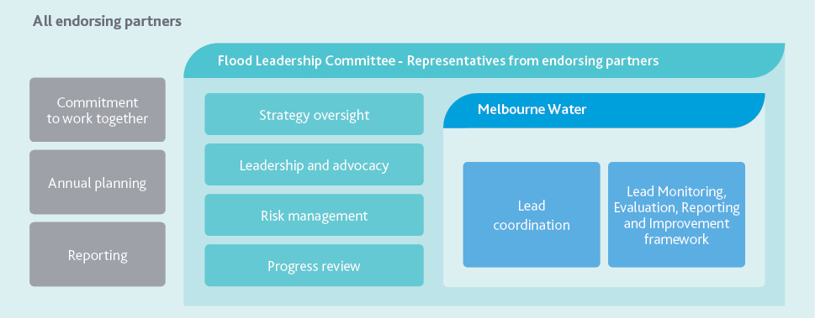

Flood Leadership Committee
The purpose of the Flood Leadership Committee is to provide strategic oversight over implementation of the strategy and actively participate in governance of the strategy to influence and support delivery of the vision, objectives and outcomes. The Flood Leadership Committee comprises up to 15 senior representatives of the endorsing partners.

The endorsement process
Agencies in the region with flood management responsibilities, including councils, emergency services and state government agencies were invited to endorse this strategy.
Endorsing partners agreed to:
- commit to the vision, objectives and directions outlined in the strategy and commit to working in partnership towards its implementation, including:
  - participating in an annual review and planning process
  - participating in reporting on progress
    - agree to all logos being included in the final Flood Management Strategy
    - commit, subject to funding, to deliver their actions (excluding councils).
Our endorsing partners will work together to commit to specific actions for councils, and to deliverables for all endorsing partners on an annual basis. An annual review and planning process will be a mechanism for reporting, reviewing and renewing commitments, as described in Table 1.
Table 1 Annual review and planning process
Prior to the annual review and planning | Annual review and planning
- Reporting on progress against the targets set in monitoring, evaluation, reporting  - and improvement plan  - Review of progress | - Discuss progress and improvement opportunities  - Ongoing review of action delivery and alignment  - Agree on clear deliverables for the year ahead

Implementation
It will take the actions of many to deliver this strategy. The action plan that accompanies this strategy contains clear actions and accountabilities.
We need to collaborate to achieve common goals, share information and skills, understand needs and opportunities across the region, engage in joint problem-solving, and coordinate processes and activities across waterways, water supply systems and catchments.
Implementation will also involve working with communities, particularly in high-flood-risk areas, to understand their needs and develop solutions.

Monitoring, evaluation, reporting and improvement
We aim to continuously improve while we are implementing this strategy. We will do this using our monitoring, evaluation, reporting and improvement (MERI) plan.
We will learn from previous experience, and update our management approaches to reflect the knowledge we gain, and to reflect the changes in our environment as they happen.

Embedding accountability, learning and continuous improvement
We have developed a monitoring, evaluation, reporting and improvement plan to embed accountability, learning, and continuous improvement into the implementation of the strategy. The plan has been developed through our governance framework and is available separate from the strategy.
A monitoring, evaluation, reporting and improvement is a structured process of developing a robust evidence base to inform decision making and program improvement. It does this by answering the following high-level questions:
- Monitoring – what is happening?
- Evaluation – what does it mean?
- Reporting – who do we tell?
- Improvement – what needs to change?
The specific purpose of this monitoring, evaluation, reporting and improvement plan is to:
- demonstrate achievements and progress towards long-term outcomes
- demonstrate the effectiveness of flood awareness, preparedness, response and recovery activities
- clarify governance arrangements and levels of participation for monitoring, evaluation, reporting and improvement activities
- demonstrate accountability to the community for how public funds have been spent
- clarify the program logic and use evidence-based strategies for floodplain management programs
- identify a learning and improvement process that will inform management decisions.
Our primary audience is our partners who will use the information and findings to make decisions and improve programs. Secondary audiences will have a general interest in our findings and include communities in flood-prone areas, community groups, developers, academia, government agencies, industry bodies and the media.

Evaluating the strategy
We have developed key evaluation questions to assess the strategy under five categories:
- impact – the measurable effect of the strategy in achieving its outcomes
- effectiveness – how well the strategy has delivered its actions and outputs
- appropriateness – the degree to which the strategy meets the needs of the community and reflects the obligations of endorsing partners
- efficiency – the extent to which the strategy can demonstrate improvements over time including value for money
- legacy – the extent to which the impacts of the strategy will continue over time.
An example of the evaluation questions is provided in Table 2.
Table 2 Key evaluation questions
Category | Strategy component to be evaluated | Example key evaluation questions
Impact | Outcomes | To what extent have strategy outcomes been achieved?  To what extent has flood risk been reduced compared with ‘do-nothing’?
Effectiveness | Actions | To what extent has the strategy been implemented as planned?
Appropriateness | Focus areas | To what extent do integrated water management solutions in flood prevention/drainage management contribute to the needs of community for flood effects mitigation?
Efficiency | Focus areas | To what extent have partnerships and co-delivery contributed to the efficient implementation of the strategy?
Legacy | Focus areas | To what extent have the long-term maintenance requirements for infrastructure been identified and planned for?  To what extent have awareness, education and education programs made a difference to long-term behaviour change?
Evaluation will involve systematically assessing the strategy and its implementation. We will use data to answer the key evaluation questions, build knowledge and inform decisions about program improvements.

Monitoring the strategy
Monitoring is the ongoing collection of data and information to understand changes over time. We will monitor our activities based on targets/measures and indicators identified for each key evaluation question, including the delivery of actions, and progress towards outcomes.
The strategy will have a small set of key performance indicators (KPIs), otherwise known as targets, that will drive strategy implementation. The five-year KPIs are included in both the monitoring, evaluation, reporting and improvement plan and the action plan.

Reporting
- Regular reporting is an important tool to ensure that we are accountable for delivering on the strategy. It provides opportunities for managers and endorsing partners who are involved in the delivery of the strategy to track their progress and to identify opportunities for improvement if required. Reporting will happen at different times throughout the strategy.
- Annual reporting will track our progress in delivering the actions in the action plan.
- Periodic reporting over the 10-years of the strategy will assess our progress towards achieving the outcomes of the strategy. The timing of this will be different for each outcome and will relate to how long it is likely to take to see change.
- Event based reporting will follow a major flood to allow us to learn from the event.

Glossary
Annual Exceedance Probability
Likelihood of occurrence of flooding in any given year usually expressed as a percentage, e.g. 1% Annual Exceedance Probability flood.
Average Annual Damage
Represents the average yearly cost of flooding in a particular area, calculated by taking the total damage caused by all flooding over a period of time and dividing it by the number of years in that period. Average annual damage provides a basis for comparing the economic effectiveness of different mitigation measures.
Catchment
The region from which all rainfall flows, other than that removed by evaporation, into waterways and then to the sea. A catchment can be defined at many different levels such as the whole river basin (e.g. the Yarra catchment) or at a very local level (e.g. individual drains).
Climate change adaptation
Adjustment in response to actual and expected climate change and/or effects, to reduce harm or take advantage of opportunities.
Coastal flooding (tidal inundation)
Increases in coastal water levels above the predicted tide level. Coastal flooding in a storm surge gives some advance notice.
Drainage system
Network of regional and local drains, roads and retarding basins.
Flash (stormwater) flooding
Inundation by local runoff caused by heavier than usual rainfall. Flash flooding from the stormwater system tends to be rapid and dangerous due to the speed and depth of flows and the lack of advance warning.
Flood
A natural phenomenon that occurs when water covers land that is normally dry.
Flood awareness
Appreciation of the likely effects of flooding, and a knowledge of the relevant flood warning, response and evacuation procedures.
Flood mitigation
Permanent or temporary measures (structural and non-structural) aimed at reducing the impact of flood. Could be planning controls, infrastructure or activities on waterways.
Flood modelling and mapping
Flood studies that map flood risks for a range of uses including land use planning, insurance and emergency response.
Flood resilience
Ability to plan for flooding as a natural and inevitable disturbance; act to mitigate risks and respond to flood events; and recognise the changing context presented by climate change and population growth while enabling the achievement of safety, liveability and sustainability goals within the region.
Floodplain
An area of land that is subject to inundation by floods up to, and including, the largest probable flood event. Areas of land may be adjacent to a creek, river, estuary, lake, dam or artificial channel. Floodplains are often valued for their ecological properties.
Fit-for-purpose flood information
Information that informs decisions about managing and reducing flood risk, including flood modelling and mapping.
Greenfield
Areas identified for urban development (residential, commercial or industrial) by state and/or local government, located on or beyond the boundaries of existing urban development.
Integrated water management
Water management approach that considers all components of the water cycle as a whole to maximise social, environmental and economic outcomes. It achieves this through the coordinated management of drainage, flooding, waterways, water supply and sewerage services.
Liveability
Wellbeing of a community, and the many characteristics that make a place somewhere people want to live. A liveable city or region meets the social, environmental and economic needs of its people. It also addresses community values and preferences for amenity, wellbeing and a sense of place.
Overlay
Planning control applied to land that requires a specific design treatment.
Planning scheme
Regulates land use and development within a municipal district. Includes state and local flood policies and controls.
Retarding basin
An extensive artificial depression in the ground to hold back water and minimise local downstream flooding.
Stormwater
Water that runs off land when it rains.
Water security
Capacity to safeguard sustainable access to adequate quantities of acceptable quality water for sustaining livelihoods, human well-being, and socio-economic development, for ensuring protection against water-borne pollution and water-related disasters, and for preserving ecosystems.
Waterway
A collective term that refers to rivers, estuaries and wetlands.
Wetland
Inland, standing, shallow bodies of water, which may be permanent or temporary, fresh or saline.

Abbreviations
Term | Definition
AAD | Annual average damage
AEP | Annual Exceedance Probability
BoM | Bureau of Meteorology
DELWP | Department of Environment, Land, Water and Planning
IWM | Integrated water management
KEQ | Key evaluation question
MAV | Municipal Association of Victoria
MEMP | Municipal Emergency Management Plan
MEMPC | Municipal Emergency Management Planning Committee
MERI | Monitoring, evaluation, reporting and improvement (plan)
MOU | Memorandum of understanding
MUSIA | Melbourne Urban Stormwater Institutional Arrangements (project)
MW | Melbourne Water
REMP | Regional Emergency Management Plan
REMPC | Regional Emergency Management Planning Committee
VICSES | Victoria State Emergency Service
VPA | Victorian Planning Authority

Bibliography
Australian Broadcasting Corporation 6 November 2018, ‘Flash flooding and flashy fashions the highlights of Melbourne Cup 2018’,
ABC News online, viewed 20 July 2020
Australian Business Roundtable 2020, Australian Business Roundtable for Disaster Resilience and Safer Communities 2020
Bastion and Latitude 2018, Flood Risk Awareness Progress Report, prepared for Melbourne Water and Victoria State Emergency Service, Melbourne
Deloitte Access Economics 2016, The economic cost of the social impact of natural disasters, Australian Business Roundtable for Disaster Resilience and Safer Communities, NSW
Department of Environment, Land, Water and Planning 2016, Victorian Floodplain Management Strategy, State of Victoria, Melbourne Department of Environment, Land, Water and Planning 2017, Plan Melbourne 2017–2050: Metropolitan Planning Strategy,
State of Victoria, Melbourne
Department of Environment, Land, Water and Planning 2019, Victoria in Future 2019: Population Projections 2016 to 2056, State of Victoria, Melbourne
Department of Environment, Land, Water and Planning 2019, Victoria’s Climate Science Report 2019, State of Victoria, Melbourne Department of Environment, Land, Water and Planning 2020, Port Phillip Bay Coastal Assessment, State of Victoria, Melbourne Emergency Management Victoria 2020, Emergency Management Manual Victoria, State of Victoria, Melbourne
Emergency Management Victoria 2020, State Emergency Management Plan, State of Victoria, Melbourne
Grose, M. et al. 2015, Southern Slopes Cluster Report, Climate Change in Australia Projections for Australia’s Natural Resource Management Regions: Cluster Reports, eds. Ekström, M. et al., CSIRO and Bureau of Meteorology, Australia
Latitude Insights 2015, Benchmarking Flood Ready Behaviour report, prepared for Melbourne Water, Melbourne
The Lowry Institute 2020, Australia and climate change
Melbourne Water 2015, Flood Management Strategy Port Phillip and Westernport, Melbourne Melbourne Water 2019, Elster Creek Catchment Flood Management Plan 2019–2024, Melbourne
Otto, Kristin 2005, Yarra: A Diverting History of Melbourne’s Murky River, Text Publishing, ebook, Melbourne
State Library Victoria 20 July 2015, ‘The great flood of 1891’ State Library of Victoria Blog, Melbourne, viewed 20 July 2020
White, Sally & staff writers 14 February 2020, ‘From the Archives, 1972: Chaos as floods batter Melbourne’, The Age, Fairfax Media, Melbourne, viewed 20 July 2020
Melbourne Water
Melbourne Water
990 La Trobe Street, Docklands, Vic 3008
PO Box 4342 Melbourne Victoria 3001
Telephone 131 722 Facsimile 03 9679 7099
978-1-921603-34-1 Online
© Copyright August 2021 Melbourne Water Corporation. All rights reserved. No part of the document may be reproduced, stored in a retrieval system, photocopied or otherwise dealt with without prior written permission of Melbourne Water Corporation.
Disclaimer: This publication may be of assistance to you but Melbourne Water and its employees do not guarantee that the publication is without flaw of any kind or is wholly appropriate for your particular purposes and therefore disclaims all liability for any error, loss or other consequence which may arise from you relying on any information in this publication. All actions in this strategy will be delivered subject to funding.

Department of Environment, Land, Water and Planning 2019, Victoria in Future 2019). Population Projections 2016 to 2056. July 2019, Victoria in Future 2019 (PDF 2.3 MB) (https://www.planning.vic.gov.au/__data/assets/pdf_file/0032/332996/Victoria_in_Future_2019.pdf)
Australian Business Roundtable 2020, Australian Business Roundtable for Disaster Resilience and Safer Communities 2020, Australian Business Roundtable website (http://australianbusinessroundtable.com.au/)
This estimate has been developed using existing and extrapolated data. Existing data included mapping of 1% Annual Exceedance Probability (AEP) flood extents (that is, a flood with a 1% chance of occurring in any given year) along waterways and regional drainage systems, and mapping of local drainage systems where available. This data was then used to make estimates of the number of properties likely to be affected in areas that are yet to be mapped for flooding. It will be revised as more data is collected over time.
CSIRO and Bureau of Meteorology 2015, Climate Change in Australia Projections Cluster Report – Southern Slopes.
Department of Environment, Land, Water and Planning 2019, Victoria’s Climate Science Report, Victoria’s Climate Science Report 2019 (PDF 6.8MB) (https://www.climatechange.vic.gov.au/__data/assets/pdf_file/0029/442964/Victorias-Climate-Science-Report-2019.pdf)
The Lowry Institute 2020, Australia and climate change, Lowy Institute (https://www.lowyinstitute.org/issues/australia-climate-change)
Department of Environment, Land, Water and Planning 2019, Victoria in Future 2019. Population Projections 2016 to 2056, July 2019, Victoria in Future 2019 (PDF 2.3 MB) (https://www.planning.vic.gov.au/__data/assets/pdf_file/0032/332996/Victoria_in_Future_2019.pdf)
Department of Environment, Land, Water and Planning 2017, Plan Melbourne 2017-2050: Metropolitan Planning Strategy Plan Melbourne website (https://www.planmelbourne.vic.gov.au/the-plan)
Benchmarking Flood Ready Behaviour, report commissioned by Melbourne Water
Flood Risk Awareness 2018, report commissioned by Melbourne Water and Victoria State Emergency Service
Flood Risk Awareness 2018, report commissioned by Melbourne Water and Victoria State Emergency Service
ABC News (https://www.abc.net.au/news/2018-11-06/melbourne-cup-day-2018-rain-rescues-flash-flooding-train-delays/10469318)
Australian Business roundtable website (http://australianbusinessroundtable.com.au)
Lowry Institute website (https://www.lowyinstitute.org/issues/australia-climate-change)
State Library Victoria website (https://blogs.slv.vic.gov.au/such-was-life/buildings-streets/the-great-flood-of-1891)
The Age (https://www.theage.com.au/national/victoria/from-the-archives-1972-chaos-as-floods-batter-melbourne-20200213-p540oi.html)
Melbourne Water (www.melbournewater.com.au)
www.melbournewater.com.au

